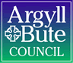

Standards and Quality Report 2024 - 2025

Garelochhead Primary and Early Learning and Childcare Centre
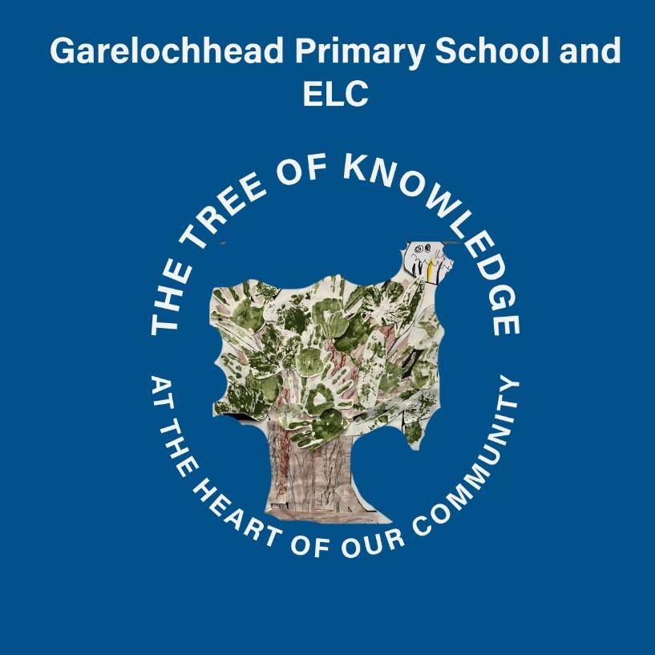


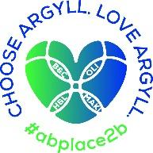

Context of the school
Including some or all of the following:
- Basic school details (roll, class composition etc.)
- school vision, value and aims;
- local contextual issues;
- factors affecting progress (e.g. staffing changes/issues)
Garelochhead Primary School and Early Learning Centre (ELC) is a small, community-oriented school located in the rural village of Garelochhead, Argyll and Bute. The school plays a central role in the local area, fostering strong relationships with families and wider community stakeholders. The current school roll is 83 pupils, with an additional 21 children enrolled in the Early Learning Centre. The relatively small size of the setting supports a nurturing, inclusive ethos and allows for a personalised approach to learning and teaching across all stages.
The school operates a mixture of composite and straight classes, reflecting the flexible and responsive structure necessary in smaller rural settings. Staff work collaboratively to ensure that our pupils experience learning that meets their individual needs. A significant factor in the school's profile is the percentage of pupils with Additional Support Needs (ASN), currently sitting at 36.14%. This underscores the importance of tailored support systems, intervention planning, and staff professional development to meet a wide range of learning and wellbeing needs.
Garelochhead Primary and ELC is guided by a clear vision and shared values: We are the tree of knowledge at the heart of our village where everyone works together to be ambitious, be kind, be respectful, and be safe. At Garelochhead Primary School and ELC, we work together to create a culture where children and young people feel included, respected and secure and where their achievements and contributions are valued and celebrated. We believe that positive relationships are key to ensuring everyone can learn and develop together.
Garelochhead serves a semi-rural community, with our SiMD profile ranged across quintiles 1 to 5; 37.96% in quintiles 1&2, 43.52% in quintile 3, and 16.66% in quintiles 4 and 5. Approximately 27% of our pupils are classed as Armed Forces.
The school receives Pupil Equity Funding (PEF) to help close the poverty-related attainment gap. The allocation of PEF is strategically aligned with the school's SIMD profile and internal data. Funding has been used to provide a Walking Bus and Breakfast Club to support attendance and engagement with targeted pupils, and to provide targeted interventions in literacy.
Progress monitoring indicates that these interventions have had a positive impact on engagement, confidence, and attainment across key stages. Improvements have been noted in both literacy and numeracy, with targeted groups showing measurable progress.
Our teaching staff allocation for session 24/25 was 6.52FTE. We also had 0.2FTE of Pupil Support Teacher time - one day per week. Our Additional Support Needs Assistant allocation was 160 per week with support provided throughout the school based on need. Our Classroom Assistant allocation was 23.75 hours. Our PSA allocation was 6.75 hours per week. In our ELC there were 3 full time CCEW, who were supported by an ELC CA for 15 hours per week.

Review of SIP | Priority 1
Ensuring wellbeing, equality and inclusion: Embed a rights respecting ethos throughout the school community.
Progress and Impact:
Priority 1 focused on embedding a rights-respecting ethos throughout the school community, aligning with national and local priorities under the National Improvement Framework and How Good is Our School 4 (HGIOS 4). This priority aimed to ensure that all learners feel safe, included, and respected, while equipping staff with the knowledge and tools to foster a nurturing and equitable environment.
- Launch and Implementation of the Positive Behaviour and Relationships (PBR) Policy
The school launched its refreshed PBR policy with the following engagement strategies:
  - Staff reviewed and engaged with the policy during August INSET.
  - Parents and carers were introduced to the policy during the "Meet the Teacher" session.
  - Pupil engagement was evident through assemblies and pupil-led initiatives like playground monitors and P1 buddies.
The success criteria were met:
  - Pupils demonstrated a strong understanding of the PBR policy, verified through pupil discussions.
  - 100% parental agreement and understanding of the policy were achieved via surveys.
  - Staff showed clarity and consistency in policy application, as evidenced by positive feedback during QI visits.
  - Class charters were established collaboratively, shared with families, and reinforced daily, ensuring the policy was visible across the school day.
- Enhancing Staff Capacity to Manage Behaviour and Promote Inclusion
The school demonstrated a strategic commitment to staff development in understanding and addressing behaviours that challenge:
  - The majority of staff successfully completed CALM’s Core Theory Course.
  - Training in the CIRCLE Framework supported the creation of inclusive learning environments, with staff using tools like the Inclusive Classroom and Participation Scales to inform personal action plans.
  - Regular coaching from the Nurture Team and Ed Psych provided continued professional learning and scenario-based support.
Targets were met or are on track:
  - Completion and passing of the CALM course by the majority of staff.
  - A reduction in PERS100C submissions from session 23/24 of 37.5% suggests early positive impact on behaviour management.
  - Analysis of SHANARRI wellbeing data (from March 25) showed quantitative measure of pupils feeling INCLUDED, with an improvement since October 2024 of 24%;
  - Staff PRD discussions indicated increased confidence and understanding in handling complex behavioural needs.
- Alignment with UNCRC and Policy Review
The comprehensive review of school and ELC policies ensured alignment with the principles and articles of the UNCRC and the school’s PBR policy. Engagement from staff, the Parent Council, and the Pupil Steering Group ensured that this process was inclusive and reflective of the whole school community.
Garelochhead Primary School achieved RRSA Silver: Rights Aware status in January 2025, reflecting their strong commitment to embedding the United Nations Convention on the Rights of the Child (UNCRC) throughout the school’s ethos and practice. Children across the school demonstrate a clear understanding of their rights and confidently discuss how these are respected and upheld within the school community. The report highlights how children are active participants in decision-making and are increasingly involved in planning, leading initiatives, and advocating for the rights of others. School and ELC policies ensure that they reflect the principles and articles of the UNCRC and staff have taken forward a consistent approach within our school community, with every child learning about a right of the month, wider achievement assemblies and rewards provided each week during assemblies for children who have been living a specific article, as observed by staff.
The feedback stated that we have created a nurturing and inclusive environment where positive relationships and respect underpin daily interactions. Children feel safe, valued, and supported. They are encouraged to express their views, and there is a strong sense of mutual respect between pupils and staff. Garelochhead Primary’s rights-based approach supports children's wellbeing and promotes equity across the school.
Next Steps: Garelochhead Primary and ELC will continue to deepen children’s understanding of rights by providing regular opportunities to explore and apply rights-based learning across the curriculum. This will include stronger links to global citizenship, sustainability, and wider societal themes through a refreshed approach to planning for IDL. Strategic planning will more explicitly reflect children’s rights, embedding them into the school and ELC improvement plans, curriculum design, and the overall vision, values, and aims.
Children should be further empowered to take the lead in rights-based initiatives, with greater opportunities to design, implement, and evaluate projects both in school and the community. Strengthening parental and community engagement is also essential, with a focus on raising awareness and promoting inclusive participation. In the ELC, rights-based practice should be embedded more consistently through child-led routines and meaningful use of rights language in daily interactions and planning.
Self-evaluation activities in May 2025, and feedback from parents and staff also indicate that consistent tracking and monitoring of interventions to ensure wellbeing, equality and inclusion require to be embedded and that work needs to continue to ensure that all staff have the confidence to plan for, and track progress of, all learners to ensure that their needs are being met appropriately. This will ensure that we are raising attainment and achievement for our most vulnerable learners through improved approaches to wellbeing and inclusion. This will be achieved through a focus on Staged Interventions with staff, increased planning, assessment and moderation within staged intervention and ensuring that environments and resources support high quality interventions and interactions.

Review of SIP | Priority 2
Design and develop a curriculum underpinned by high quality learning, teaching and assessment and reflective of our school community.
Progress and Impact:
Strategic Priority 2 aimed to design and develop a curriculum underpinned by high-quality learning, teaching and assessment that is reflective of the Garelochhead Primary and ELC community. The priority aligned with national drivers, the school’s refreshed Vision, Values and Aims, and the aspiration to enhance pupil ownership, engagement, and progression. However, the full scope of this priority was not met within the intended timescale.
Progress and Implementation
Although the strategic priority was not fully achieved, the school made some headway in certain areas of the curriculum:
- Implementation of New Planning Documents in Literacy and Numeracy
Staff have developed and introduced new termly planning for Literacy and Numeracy. These are supported by Literacy and Numeracy frameworks building consistency, progression and coherence across stages, and are informed by national guidance and assessment benchmarks. Teachers report improved clarity in planning and greater alignment between intended learning, assessment and progression. Early evidence suggests these new documents have had a positive impact on learner confidence, particularly in writing. Pupil survey data shows an increase from 23% of those who said they felt mostly or very confident about their writing, to 35%.
- Development of digital Learning Logs across the school and ELC (ELC - P3 Seesaw, P4-7 Google Classroom)
Digital Learning Logs provide pupils with a personalised digital space to reflect on their learning experiences, record achievements, and set next steps. By engaging with these tools regularly, children are developing a deeper understanding of themselves as learners. The use of digital technologies supports pupil voice and choice and encourages ownership of learning through self-evaluation and goal setting. Qualitative evaluation from staff demonstrated increased engagement and motivation among pupils, with learners demonstrating greater confidence in discussing their progress and identifying areas for improvement. These logs also provide a valuable platform for sharing learning with parents and carers, further strengthening the home-school partnership.
- Collaborative Planning for Interdisciplinary Learning (IDL)
Staff have demonstrated collegiate working by planning interdisciplinary learning topics across Social Studies and Sciences with pupil choice being a key driver. Planning sessions have involved shared ideas, agreed learning intentions, and integrated approaches that foster creativity and pupil engagement. The IDL planning has also allowed for the development of more meaningful links with the ELC, and to allow staff to build their understanding of progressive learning and teaching.

Next Steps:
Significant work is needed to develop a coherent, progressive, and well-structured curriculum that fully reflects national expectations with pedagogy research and understanding of effective learning, teaching and assessment supporting all developments.
At present, there is limited evidence of a shared understanding of highly effective learning, teaching and assessment and considerable focus required on how this supports a clear, consistent curriculum across the nursery and primary. Curriculum planning currently focuses on discrete subject areas, with less emphasis on interdisciplinary learning, skills progression, and real-life contexts and the effective pedagogies that work alongside this context for learning.
Opportunities for learners to develop the four capacities and to engage in meaningful, relevant experiences are not yet consistently embedded. There is also a need to ensure greater personalisation and choice for learners, particularly in the upper stages. Staff are beginning to engage in professional dialogue around curriculum design and effective pedagogy, with work planned to further support and develop staff confidence and shared understanding in this area.
To move forward, the school will prioritise the development of a clear, values-driven curriculum rationale that supports the school policy within learning, teaching and assessment. This will be accompanied by a robust framework for curriculum progression, including clear pathways in other curricular areas to enhance the progression frameworks in place for literacy, numeracy and HWB. Staff will be supported to develop their understanding of learning and teaching the skills for learning, life and work. Greater collaboration with learners, families, and partners will also help shape a more responsive and inclusive curriculum.

Review of SIP | Priority 3
Raising attainment and achievement: Focus on raising attainment in reading through high quality learning and teaching and data driven interventions.
Progress and Impact:
Strategic Priority 3 set out a clear and targeted approach to improving attainment in reading across Garelochhead Primary and ELC by embedding high-quality learning, teaching, and assessment, and by utilising data to drive interventions. Through a well-structured action plan, strong staff engagement, and effective use of resources, this priority has been successfully met. The outcomes reflect tangible improvements in both attainment and engagement in reading, alongside professional development gains for staff and enhanced pupil experiences.
Structured Literacy and High-Quality Learning
A systematic and structured approach to the teaching of reading was implemented throughout the school, with the Read Write Inc. programme effectively embedded in P1–P3. Across all stages, vocabulary development and reading fluency strategies were consistently applied, and comprehension skills were developed through questioning, discussion, and critical engagement with texts. In the ELC, staff successfully created reading-rich environments tailored to developmental needs, ensuring reading opportunities were both accessible and engaging.
Monitoring data confirmed a 5% increase in the number of pupils achieving or exceeding expected levels in reading, meeting the success criteria set out in the improvement plan. Observations confirmed a high level of pupil engagement, and learners demonstrated increasing independence and confidence in their reading skills.
Professional Learning and Collegiate Development
All teaching and ELC staff identified personal development goals related to reading pedagogy using national and local resources such as the Argyll and Bute Framework for Learning, Teaching and Assessment, and the Literacy Checklist. Staff completed relevant professional learning and participated in collegiate sessions which focused on targeted improvements. Learning observations throughout the session reflected improved classroom practice, with almost all children observed to be actively engaged and participating in a range of well-planned reading activities.
Quality improvement visits validated the presence of high-quality learning and teaching in reading across the school and ELC. Staff were consistently applying evidence-based strategies to support learners' reading development, with an emphasis on pace, challenge and depth.
Use of Performance Information to Support Targeted Interventions
Regular formative and summative assessment practices were embedded, with staff using assessment data effectively to inform planning, support and challenge. XBRA and ACEL data were reviewed at multiple points during the session, informing targeted interventions and individualised support strategies. These were particularly successful in narrowing attainment gaps and ensuring pupils had clear pathways to progress in their reading.
Tracking meetings provided opportunities for staff to reflect on pupil progress collaboratively, ensuring that interventions were responsive and impactful. Pupils also benefited from increased awareness of their own progress and areas for development, contributing to their ownership of learning.
Literacy-Rich Environments and Pupil Engagement
The school created a vibrant and inclusive reading culture. A range of physical and digital reading materials were made accessible across the school and ELC, and pupils were empowered to select texts that reflected their interests. A librarian programme was successfully introduced, giving pupils leadership opportunities and promoting responsibility and engagement in reading initiatives.
During Term 1, home reading initiatives, and open access to the school library ensured that all families had access to reading materials and this reinforced the importance of a shared responsibility for creating a learning culture. During the October holidays, the Parent Council organised a readathon which 40% of our families took part in. Partnership with families has been further strengthened through the training of an ELC staff member in Bookbug.
Pupil surveys showed increased enjoyment and motivation around reading:
Pre-survey: 20% enjoyed reading very much and 50% thought they were a good or very good reader.
Post-survey: 50% enjoy reading very much and 85% think they are a good or very good reader.

Attainment data for Session 24/25 shows the following:
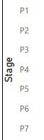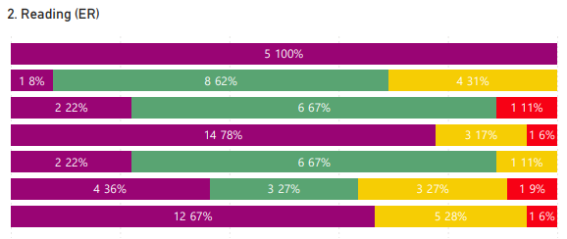

When compared against data from session 23/24, we can make the following statements:
Reading Attainment at P1 has risen by 38.46%, compared to the previous cohort.
At P2, there has been an increase of children working at the appropriate level within XBRA of 15%.
At P3, there has been an increase of children working at the appropriate level within XBRA of 18%.
At P7, there has been an increase of children working at the appropriate level within XBRA of 8%.
Next Steps:
Interrogation of data shows that further improvement work in reading is required next session. It is anticipated that the focus in next sessions' learning, teaching and assessment work that aligns with robust progressive planning in Literacy will support further improvements in this area. This will include:
- Progression Frameworks agreed and used to support all planning within Literacy.
- Development of school TERMLY planning across Literacy to support the coverage of Es and Os
- Development of school WEEKLY Progressive planning, effective linkage and coverage of Es and Os, within short planning blocks.
- Termly moderation of planning and assessments for iIdentifying learning and wider achievement gaps, evaluating learning, teaching and assessment, communicating achievement, progress and attainment, setting personal learner goals,Identifying trends and patterns.
- Building staff capacity in features of highly effective learning and teaching within literacy, and upskilling staff with the use of appropriate resources to support this.

Review of SIP | ELC Priority
Focus Area: Early Level Planning, Tracking, Assessment and Curriculum Design
Progress and Impact:
Some progress has been made in developing more robust and responsive approaches to planning, tracking, and assessment. Practitioners have engaged in professional dialogue to review and refine planning formats to ensure they are developmentally appropriate and reflect children’s interests and stages of learning. This has led to more responsive and flexible planning that takes greater account of real-time observations and emerging learning needs.
Staff have begun to incorporate more focused observations linked to the key aspects of learning, and evidence of progress is beginning to be recorded more systematically. However, consistency across the team and alignment with progression pathways remains an area for further development. Staff confidence in using assessment information to inform next steps is improving, but this requires continued focus and support.
Some progress has been made in implementing and embedding systems to track children’s progress across literacy, numeracy and health and wellbeing. Staff are beginning to use Early Level progression pathways in line with the primary school planning to support tracking in literacy and numeracy. These are increasingly being used to inform planning discussions and identify appropriate next steps.
The Argyll and Bute Developmental Milestones are being used more consistently to track and support children’s health and wellbeing, particularly in relation to emotional regulation, communication, and physical development.
The ELC team have made some progress in using the learning environment more intentionally to support interdisciplinary learning. Staff have reflected on the layout and resourcing of the environment to create spaces that promote curiosity, creativity, and holistic development. The introduction of loose parts play, small-world areas, and outdoor learning opportunities has supported connections across literacy, numeracy, expressive arts and STEM.
Planning formats now more regularly identify interdisciplinary learning opportunities across experiences and outcomes, although this is still at an early stage. There is growing evidence that children are engaging with rich contexts for learning, and staff are beginning to capture how these experiences connect across curriculum areas. Continued focus on planning for depth and progression will further enhance this work.
The ELC team have made some progress in using the learning environment more intentionally to support interdisciplinary learning. Staff have reflected on the layout and resourcing of the environment to create spaces that promote curiosity, creativity, and holistic development. The introduction of loose parts play, small-world areas, and outdoor learning opportunities has supported connections across literacy, numeracy, expressive arts and STEM.

Next Steps: Improve Curriculum, pedagogy and learner voice in the ELC
Staff Development:
Revisit professional learning and understanding of Realising the Ambition and The 3 Assets framework to support professional development with a focus on coordinating and connecting schemas in play pedagogy

Gather information on key features of the local community through social and economic structures surrounding learners

Practitioners will work collectively to summarise/identify key points throughout RTA to become more familiar with the document.

All staff to select an area of ELC leadership to drive forward improvements that are relevant to the context of Garelochhead

Build on existing practice in relation to staff sharing areas of expertise with others

Engage more systematically in professional reading over time with a particular focus on Highly Effective learning and engagement and quality of interactions in our setting

Actively contribute to the culture of trust and improvement, use coaching model to guide progress in a more systematic way moving forward (focusing particularly on maximising use of time to ensure positive impact/outcomes)

Literacy and Numeracy:
Effectively use the progression frameworks for Literacy and Numeracy to pace coverage of Es and Os for N3/N4/N5 stages

Practitioners to show confidence in tracking and monitoring of literacy and numeracy and share robust evidence of children’s levels

Use tracking of Es and Os for individual children to understand individual children’s schematic play and level of attainment in EY

Develop a robust and confident observation system for all staff to support continued work on quality of interactions, engagement and assessment of children’s development.

Practitioners will work collaboratively using observations for different purposes - what are the most effective ways in which we can carry out observations?

Practitioners will use PLPs and floor books to show knowledge of the children, families and community opportunities within the St Joseph’s / Helensburgh area

Practitioners to include learners more in planning and leading learning including:
- Involving learners in sharing their views about the setting.
- Learner journeys to be developed within the setting
Floor Books capture and collate the voice of learners as they develop in the setting through the year

1.1 Attainment Data
Attainment of Literacy Curriculum for Excellence levels 2020/21, 2021/22, 2022/23, 2023/24 and 2024-2025 (teacher judgement – confirmed levels – 5 year trend).
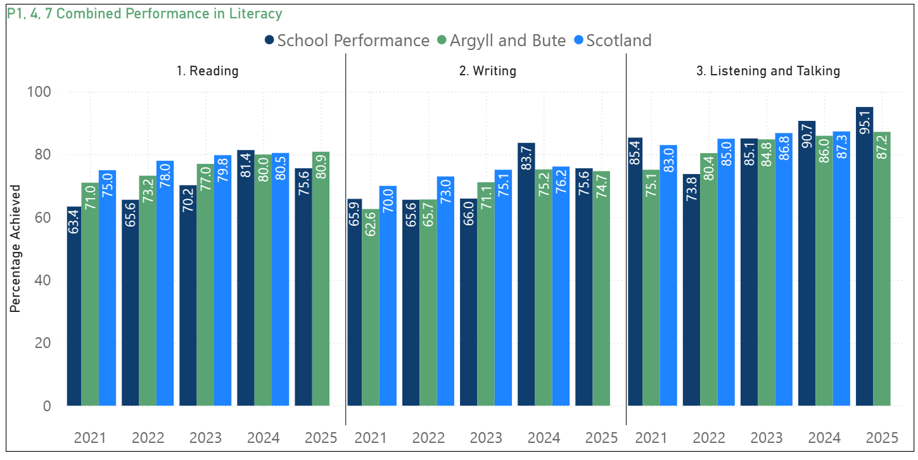

Please Note:
The above data (1.1 and 1.2) reports achievement of a level – P1/P4/P7 combined.
Due to the Covid 19 pandemic, there was no collection of ACEL data by the Scottish Government in 2020.

Reading
- School performance has steadily improved from 63% in 2021 to 80% in 2025, narrowing the gap with both the Argyll & Bute and Scotland averages.
- The local authority and national levels remain consistently higher than school results, but the gap has reduced over time.

Writing
- Writing has shown a positive upward trend, with school performance rising from 62% in 2021 to 75% in 2025.
- The school has remained slightly below the Argyll & Bute and Scotland averages but is now broadly in line, showing improvement since 2023.

Listening and Talking
- Performance in Listening and Talking started higher than Reading/Writing at 75% in 2021 and increased consistently to 86% in 2025.
- The school is broadly in line with both local and national averages throughout, with strong performance in 2024 and 2025, where the school closely matches or slightly exceeds the comparator averages.

1.2 Attainment Data
Attainment of Numeracy Curriculum for Excellence levels 2020/21, 2021/22, 2022/23, 2023/24 and 2024-2025 (teacher judgement – confirmed levels – 5 year trend).
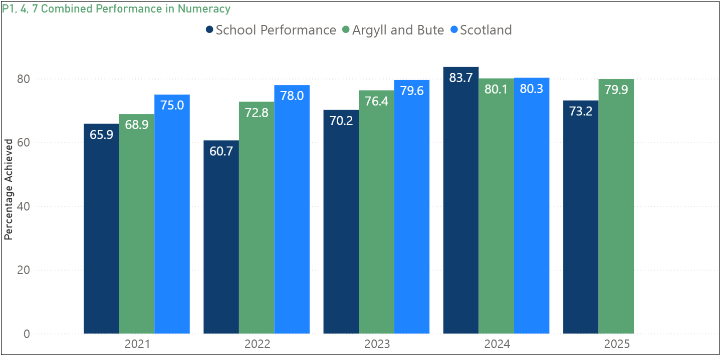

Please Note:
The above data (1.1 and 1.2) reports achievement of a level – P1/P4/P7 combined.
Due to the Covid 19 pandemic, there was no collection of ACEL data by Scottish Government in 2020.
- In 2021, school performance (65.9%) was below both Argyll & Bute (68.9%) and Scotland (75%).
- A dip occurred in 2022, with the school falling to 60.7%, widening the gap with local (72.8%) and national (78%) levels.
- From 2023, attainment improved significantly, rising to 70.2%, narrowing the gap with comparators.
- A peak was achieved in 2024, with school performance at 83.7%, surpassing both Argyll & Bute (80.1%) and Scotland (80.3%).
- In 2025, attainment dropped to 73.2%, below both comparators (79.9%), though still higher than early 2020s levels.
Numeracy attainment has shown fluctuation, with a notable dip in 2022 followed by a strong peak in 2024 where the school outperformed both local and national averages. Despite a decline in 2025, overall performance remains improved compared with 2021, highlighting progress while indicating the need for consistency in sustaining higher levels of attainment. Staff moderation discussions have already highlighted the need for continued focus on high quality teaching and learning in numeracy and for this to be a renewed focus for professional learning.

Wider achievements
- What opportunities for wider achievement were offered?
- What systems are in place to track and monitor participation?
- How have you addressed any gaps in participation?
In response to ongoing feedback from pupils and parents, we continued to strengthen our approach to extra-curricular opportunities during session 2024/25, intentionally protecting time and space for staff to support a diverse and inclusive club’s programme. Pupil voices remained central to planning; children were consulted during House sessions about the kinds of clubs they would like to see offered. A rolling programme was created across three terms, allowing for a wide range of experiences and enabling as many pupils as possible to participate. Approximately 70% of pupils engaged in these clubs, which were run by both teaching and support staff.
Staff undertook training in Bikeability, which enabled us to offer this valuable cycling safety programme to our Primary 6 pupils for the first time. In addition, staff accessed training in tennis coaching, enriching our PE and extra-curricular offer. We were proud to take part in the Christian Aid Girls' Football Tournament and Christian Aid Netball Tournament, promoting both sporting participation and global citizenship values through these inclusive and well-supported events. Garelochhead Primary also took part in cross country with local HALCO schools. To ensure equity of access, the school invested in kits and footwear to support participation for all pupils, regardless of personal circumstance.
Leadership opportunities were again a strong feature of our session. All pupils and staff were involved in electing our four House Captains (P7) and Vice Captains (P6) during Term 1. Candidates prepared and delivered campaign speeches with support from their peers and presented to their Houses at assembly. As a result of this process, pupils developed confidence in public speaking and an understanding of democratic decision-making. Elected Captains and Vice Captains represented the school throughout the year by gathering pupil views and assisting during school visits and events, where they served as guides and helped with hospitality. The impact of this was to strengthen pupil voice across the school and provide meaningful opportunities for leadership and responsibility. Additionally, each class elected a representative to our Garelochhead Guardian Committee, and these reps were responsible for taking forward our Rights Respecting School journey. As a result of their commitment and collaborative work, the school achieved the Silver Award, and the impact of this was to ensure that children’s rights are firmly embedded in the ethos and culture of the school.
As part of our commitment to performing arts and community engagement, all pupils from P1–P3 participated in our Christmas nativity. This was performed on three occasions: to fellow pupils, to parents and carers, and to members of the local Oasis group and grandparents. All classes and stages experienced high quality learning experiences in music and were given the opportunity to demonstrate their skills in front of an audience through our church services at Christmas, Easter and at the end of term. Primary 3-7 pupils all received lessons in playing the recorder. All our pupils, from ELC to Primary 7 demonstrated their learning of Scottish Culture at our Burns Afternoon which was attended by 100% of our families.
Enterprise activities continued to be a focus across the school, with each class developing small-scale enterprises during the session. Pupils sold their produce at the Parent Council Christmas Fayre. Many of these projects incorporated natural materials gathered from our local woodlands and beaches, or recycled materials, embedding principles of sustainability and responsible citizenship.
Every class took part in planning, rehearsing, and delivering an assembly, shared with both peers and members of the community. All children were included, with roles tailored to their individual strengths, preferences, and needs, ensuring that every voice was heard and valued.
During session 2024/25, we successfully enhanced how we track and celebrate wider achievement across the school. We introduced regular wider achievement assemblies, providing opportunities to recognise and celebrate pupils’ achievements both within and beyond school. A new system was established to enable parents, carers and pupils to share out-of-school successes, which were then recorded and celebrated during assemblies and within classrooms.
Next steps:
1. Develop our Learning Logs to allow pupils to record wider achievements and recognise achievements linked to the four capacities of Curriculum for Excellence
2. Strengthen Community and Parental Engagement
Build stronger links with parents, carers, and local community organisations to support and celebrate wider achievement. This includes creating regular opportunities (e.g., Wider Achievement Weeks, Learning Showcases) for families to share and celebrate children’s achievements and inviting families and community partners to contribute to school clubs and enterprise projects.
3. Embed Wider Achievement in Strategic Planning and Reporting
Ensure that wider achievement is a key component of the school’s self-evaluation, improvement planning, and reporting processes. Track pupil participation using a systematic approach, analyse data to identify gaps in engagement, and use this information to target support.

Pupil Equity Funding
Summarise progress and next steps in relation to pupil equity funding

PEF Focus: Attendance and Engagement
Intervention: Walking Bus and Breakfast Club
Data analysis from session 2023/24 identified that a group of pupils, particularly those from single parent families, were experiencing persistent challenges with attendance, late-coming and readiness to learn. These barriers were impacting engagement, wellbeing and attainment. In response, Pupil Equity Funding for session 2024/25 was used to continue our Walking Bus and Breakfast Club, aiming to reduce inequity and improve outcomes for targeted learners. Attendance was prioritised for identified pupils but remained open to all to promote inclusion and reduce stigma.
Progress and Impact
- The baseline for attendance during Terms 3 and 4 within the targeted pupil group increased by 4% from Terms 1 and 2. Late-coming incidents for this group reduced by 47%, supporting smoother transitions into learning at the start of the day.
- Walking Bus pupils arrived on time, ready to learn, and developed positive daily routines.
Engagement and Readiness to Learn:
- Staff reported improved morning focus and emotional regulation among Breakfast Club attendees.
- Pupils demonstrated greater readiness to engage in learning tasks from the outset of the school day.
- Children reported feeling “more ready” and “less rushed” (pupil voice feedback).
Wellbeing and Inclusion:
- Breakfast Club fostered calm, nurturing interactions and supported the social and emotional needs of our most vulnerable learners.
- Pupils benefited from increased positive relationships with staff in an informal setting.
- The Walking Bus enhanced pupil confidence, independence, and built positive connections.
Family Engagement:
- Parents reported reduced stress in the mornings and improved punctuality at home.
- Parental feedback was consistently positive, with increased uptake across the year.
Next Steps
- Sustain and Develop: Continue both interventions in 2025/26, with a focus on increasing reach and maintaining consistency.
- Extend Partnerships: Explore links with local businesses and third-sector partners to enhance the resourcing of the Breakfast Club.
- Embed in Tracking: Integrate pupil participation in wider wellbeing and engagement tracking to further analyse the long-term impact on attainment.

PEF Focus: Raising Attainment in Literacy for Targeted Learners
Intervention: 5 Minute Literacy Box
Pupil Equity Funding (PEF) for session 2024/25 was directed toward improving outcomes in literacy for a group of identified learners living in SIMD Quintiles 2 and 3. Baseline assessments and teacher professional judgement highlighted gaps in phonics, decoding and early spelling patterns among these pupils, which were impacting reading fluency and writing accuracy.
To address this, the 5 Minute Literacy Box was introduced as a daily, targeted intervention for individuals and small groups. The resource was selected for its evidence-based, structured, and time-efficient approach to improving phonological awareness, high-frequency word recognition and spelling.
- Targeted pupils from P2–P5 received twice weekly 1:1 or small group sessions, delivered by pupil support teachers.
- The intervention was delivered 5 days per week, with sessions built into the literacy support timetable and regularly monitored by the Head Teacher.
- Baseline, mid-point, and end-of-session data were collected using literacy assessments and teacher judgement against CfE benchmarks.

Progress and Impact
Literacy Attainment:
- 81% of pupils participating in the intervention demonstrated improvement in core literacy skills.
- 68% of pupils made measurable gains in phonological awareness and decoding, based on before-and-after phonics screening.
- 61% of pupils increased their reading fluency scores by one or more levels, as assessed through PIRA assessments.
Pupil Engagement and Confidence:
- Pupil voice feedback indicated increased confidence and enjoyment in reading and spelling tasks.
- Pupils stated they felt "more able to sound out tricky words" and "less stuck when writing."
- Staff noted improved participation and independence during core literacy lessons.

Next Steps
- Extend the Use of the 5 Minute Literacy Box into P6 for identified pupils still requiring targeted phonics/spelling intervention.
- Track Long-Term Impact by monitoring the sustained literacy progress of pupils who completed the intervention earlier in the session.
- Share Practice across stages and clusters to support consistency in the use of short, focused interventions and ensure effective deployment of PEF moving forward.

