



*Garelochhead Primary School*

*Feorlin Way*

*Garelochhead*

*G84 0DG*

Groupcall Xpressions App

Receive notifications from your child’s school on your mobile phone!

**Groupcall Xpressions** is a new service created by the award-winning school communication company Groupcall Limited. This exciting new service is now available for parents to ensure communication for everyone is easier and more effective.

The app is completely free of charge to you and can be installed on your mobile phone or tablet. It currently supports both Apple iOS and Android devices (with Windows mobile to follow) and you’ll be able to receive information from your child’s school.

If you have children in different schools within Argyll and Bute you will be able to receive information on multiple children within the same app.

**What do I need to do now?**

Please download the app from your usual App store. You will be prompted to enter the email address and mobile phone number that your child’s school currently hold as contact details for you. If your details don’t match the App won’t download. Simply email your details to [*enquiries-garelochhead@argyll-bute.gov.uk*](mailto:enquiries-garelochhead@argyll-bute.gov.uk)and wait for a confirmation from the school that your details have been updated. It can take up to 48 hours for changes to take effect. You’ll need to make sure you keep contact details up to date in future to maintain access to the Xpressions App.

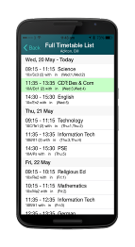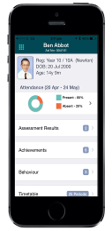

You can access information and support at the following website <http://parents.groupcall.com/>

Communications to parents will primarily be by email or push notifications using the Xpressions App, when the communication is standard to all parents, such as advising of school holiday dates or charity days in the school. Where we need to communicate individually with parents the method will be determined by the nature of the message.

**Please note** – the Xpressions App requires you to be connected to wi-fi or data in order for the push notification to be downloaded. You may incur costs if you do not have a data package or exceed your data limit on your mobile device. However you can amend settings within the Xpressions App to download the notifications when connected to wi-fi only.

If you have any questions about the use of this app or future communications from us please contact the school office on***01436 810322.***