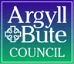

Standards and Quality Report 2025 - 2026

Garelochhead Primary School and Primary ELC

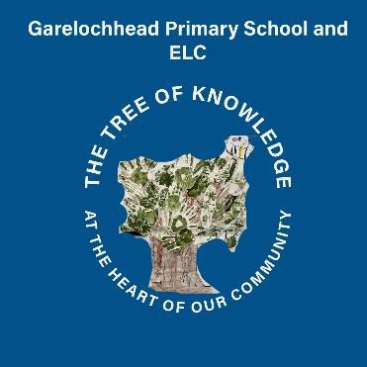

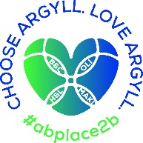


Context of the school
Including some or all of the following:
- basic school details (roll, class composition etc.)
- school vision, value and aims;
- local contextual issues;
- factors affecting progress (e.g. staffing changes/issues).

Garelochhead Primary School and Primary Early Learning Centre (ELC) is a small, non-denominational, community-oriented school located in the rural village of Garelochhead, Argyll and Bute. The school plays a central role in the local area, fostering strong relationships with families and wider community stakeholders. The current school roll is 70 pupils, with an additional 24 children enrolled in the Early Learning Centre. The relatively small size of the setting supports a nurturing, inclusive ethos and allows for a personalised approach to learning and teaching across all stages.
Our teaching staff allocation for session 25/26 was 6.2FTE including a Head Teacher who joined the school in November 2025. An Acting Principal Teacher was also recruited in November 2025 to cover the substantive Principal Teacher’s maternity leave. They are class committed 3.5 days per week. In addition, we had 0.2FTE of Pupil Support Teacher time, equating to one day of support per week.
The school had four composite classes this session: P2/1, P4/3, P5/4 and P7/6. Staff work collaboratively to ensure that our pupils experience learning which meets their individual needs. A significant factor of the school's profile is the percentage of pupils with Additional Support Needs (ASN), which currently stands at 32.86%. This highlights the importance of tailored support systems, targeted intervention planning, and ongoing staff professional learning to meet a wide range of learning and wellbeing needs.
Our Additional Support Needs Assistant allocation was 100 hours per week, with support provided across the school based on need. Our Classroom Assistant allocation was 23.75 hours, and our PSA allocation was 6.75 hours per week.
Within our ELC, a full time Lead Practitioner joined the setting in October 2025, working alongside three full time CCEWs, one part time CCEW (three days), with additional support from an ELC CA for 15 hours per week. The ELC is made up of one playroom and one outside play area which can be accessed by the children at any time.
Garelochhead Primary and Primary ELC is guided by a clear vision and shared values: The tree of knowledge at the heart of our community where everyone works together to be ambitious, kind, respectful, and safe. At Garelochhead Primary School and Primary ELC, we work together to create a culture where children and young people feel included, respected and secure, where their achievements and contributions are valued and celebrated. We believe that positive relationships are key to ensuring everyone can learn and develop together.
Garelochhead serves a semi-rural community with our SIMD profile ranging across Quintiles 2 to 5 as identified below:
- Q2 – 49%
- Q3 - 43%
- Q4 & Q5 - 8%
Approximately 19% of all pupils were in receipt of free school meals and 31% of our pupils are from Armed Forces families.
The school receives Pupil Equity Funding (PEF) to help close the poverty-related attainment gap. The allocation of PEF is strategically aligned with the school's SIMD profile and internal data. Funding has been used to provide a Walking Bus and Breakfast Club to support attendance and engagement with targeted pupils, and to provide targeted interventions in literacy and numeracy.
In December 2025 the ELC was inspected by the Care Inspectorate. The nursery received gradings of Good for Leadership and Children Play and Learn. The ELC received a grading of Very Good for Children are Supported to Achieve.
In May 2026, the school was inspected by HMIE. Final gradings and the report are still to be published.

Review of SIP | Priority 1
Improve approaches to learning, teaching and assessment
Progress and Impact:

All staff completed agreed termly assessments across the four main organisers in Literacy and Numeracy/Mathematics on three occasions this session, ensuring a consistent, systematic whole school approach to assessment, tracking and monitoring. Staff now have more reliable and comparable attainment data, enabling earlier identification of learners requiring support or challenge and more targeted interventions.

Writing criteria was created in line with ALP measures and implemented consistently across the school to support progression, moderation and high-quality learning and teaching. Teachers use the criteria regularly during planning, assessment and in providing feedback to learners, facilitating more focused discussions around strengths and areas for improvement for learners. This also led to greater pupil engagement in self and peer assessment, and improved consistency in approaches to evaluating attainment and achievement across the school. All teachers agree or strongly agree (May 2026) that implemented criteria supports progression, moderation and focused learning and teaching, enabling children to make progress in their learning.

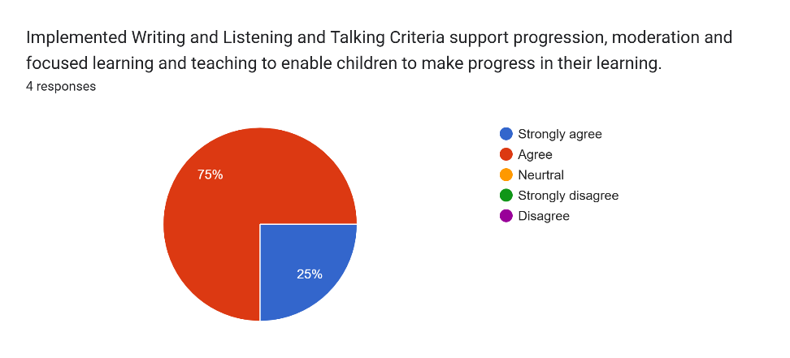

Staff use assessment information alongside a wide range of evidence including jotter monitoring, professional dialogue, learner discussions and classroom observations, to identify gaps in learning and emerging attainment patterns for children identified as Not on Track or Working Towards within Literacy (Reading and Writing) and Numeracy/Mathematics organisers across P1–P7. This strengthened staff understanding of individual learner needs and enabled earlier identification of barriers to progress. As a result, targeted interventions and support strategies were more effectively informed and matched to identified areas of need. The increased use of triangulated evidence also improved the accuracy and consistency of professional judgement across the school, supporting more robust tracking of attainment and progress over time.

Targeted interventions, including Read Write Inc. and SEAL, were introduced to support learners identified as requiring additional support in Literacy and Numeracy. The implementation of these interventions provided a more structured and consistent approach to meeting identified learning needs and enabled staff to deliver focused support aligned to specific attainment gaps. Early evidence from tracking and monitoring indicates increased learner engagement, improved confidence and progress for targeted children, particularly in key areas of reading, phonological awareness and numeracy development. Staff reported greater confidence in using intervention approaches and in monitoring the impact of targeted support. The use of these interventions has strengthened the school’s capacity to provide timely support and contributed to a more targeted approach to raising attainment across identified groups of learners

Staff engaged in termly moderation of forward planning through collaborative, collegiate activities with the Senior Leadership Team and peers. These moderation opportunities provided a structured approach, through devised formats, to reviewing planning expectations, progression, pace and curriculum coverage across stages. Professional dialogue during moderation sessions supported staff to share effective practice, reflect on approaches to planning, ensuring greater consistency in expectations when planning across the curriculum. Moderation activities also supported improved alignment between assessment evidence, planned learning and targeted next steps. Monitoring evidence indicates that planning became more focused, responsive and learner-centred throughout the session, contributing to improved coherence and continuity in learning experiences across the school.

Termly class Tracking and Monitoring meetings were held across the school to strengthen approaches to evaluating learner progress, attainment and achievement. These meetings provided a structured opportunity for teaching staff and the Head Teacher to engage in focused professional dialogue around individual learners, cohorts and whole school attainment trends.

Through the tracking and monitoring process, staff were able to identify learning and wider achievement gaps more effectively, evaluate the impact of learning, teaching and assessment approaches, and identify emerging trends and patterns across stages. This enabled earlier intervention and more targeted support for learners requiring additional challenge or support. Discussions around achievement, progress and attainment also improved the consistency and quality of professional judgements across the school, across all curricular areas. As a result, progress and achievement data information is more accurate throughout the school.

Feedback evidence was gathered from all teachers in May 2026 to support this.

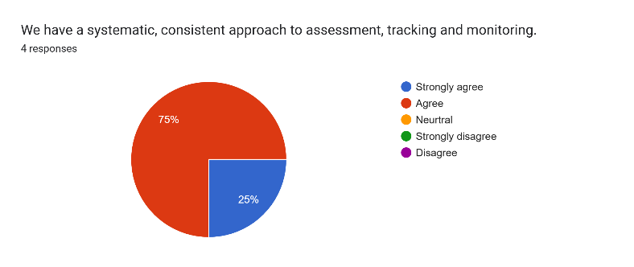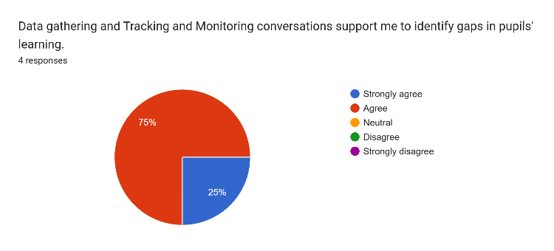

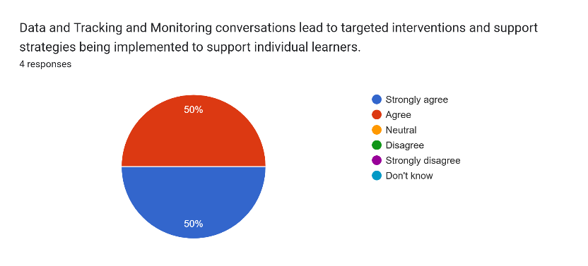

This session, we worked collaboratively with staff, parents/carers and pupils to refresh our school Learning, Teaching and Assessment policy to ensure consistency in approaches towards providing high quality learning and teaching experiences for all learners. The refreshed policy provides a clear framework for effective practice, supporting improved learner engagement, progression and achievement.

All teachers also engaged in focused collegiate professional learning linked to the features of high-quality learning and teaching, building from the features underpinned in the refreshed LTA policy. Through collaborative discussion, self-evaluation and professional dialogue, staff developed a shared understanding of effective classroom practice and agreed key expectations for teaching and learning across the school. As a result of this work, a High-Quality Lesson Rubric was created and implemented in line with HGIOS4 and OCTF – Thriving Together to provide greater clarity, consistency and focus in teaching practice.

The rubric has supported staff to reflect more effectively on their practice and has strengthened professional dialogue during monitoring, feedback and collegiate activities. Early evidence from classroom observations indicates increased consistency in lesson structure, learner engagement and the use of clear learning intentions and success criteria across stages. Staff have increased confidence in identifying strengths and next steps within their practice, contributing to a more reflective and improvement focused culture.

Staff also engaged in peer moderation activities throughout the session, providing opportunities to observe practice, share effective approaches and develop greater consistency in professional judgement across the school. These collaborative approaches strengthened professional dialogue and supported staff to reflect more effectively on their own practice as indicated in feedback gathered from teachers in May 2026.

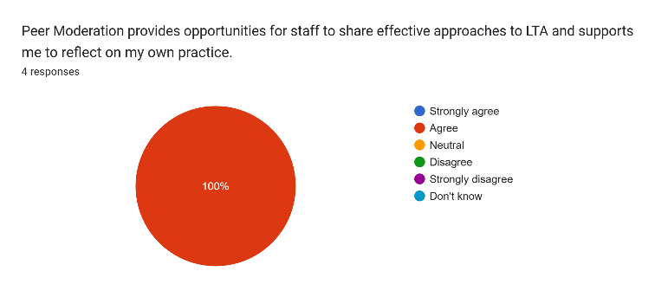

The implementation of the rubric has supported greater consistency in learner experience across the school and strengthened the school’s approach to continuous improvement in learning and teaching.

Agreed Progression Frameworks were implemented across the school and are now consistently used to support planning within Literacy and Numeracy. This has enabled staff to plan with clearer progression and greater consistency in learning experiences and expectations across all stages. The development of termly planning formats within Literacy and Numeracy strengthened staff understanding of curriculum coverage and ensured more systematic coverage of Experiences and Outcomes. Feedback from Teachers in May 2026 also supports this.

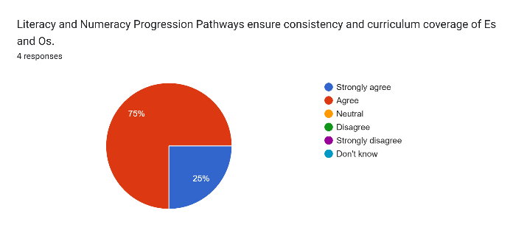

In addition, revised weekly planning approaches were introduced to support shorter, more focused planning blocks and to ensure a clear “golden thread” between long-term, medium-term and daily learning experiences. This has enabled staff to make stronger links between assessment, learning intentions, success criteria and planned next steps for learners as is indicated by all staff in May 2026 as identified below.

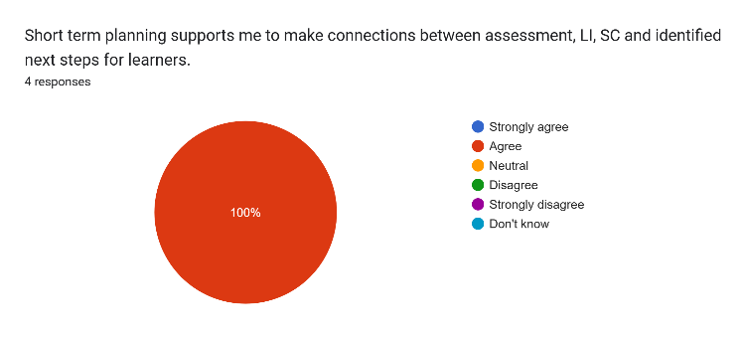

As a result, staff reported increased confidence in curriculum planning and progression, and monitoring evidence indicates greater consistency in the delivery of Literacy and Numeracy across the school. Learners experienced more coherent and progressive learning experiences, with clearer connections between prior learning, current learning and next steps. The implementation of these frameworks has strengthened curriculum continuity in Literacy and Numeracy/Mathematics, supporting more responsive teaching approaches and contributing to improved consistency in learning and teaching across P1–P7.

In writing, all children in P1, P2, P3, P7 have demonstrated increased attainment by 1 or more XBRA levels this session identified through progress and achievement.

In writing, most children in P4, P5, P6 have demonstrated increased attainment by 1 or more XBRA levels this session identified through progress and achievement.

In numeracy, all children in P1, P2, P3, P4, P7 have demonstrated increased attainment by 1 or more XBRA levels this session identified through progress and achievement.

In numeracy, most children in P5, P6 have demonstrated increased attainment by 1 or more XBRA levels this session identified through progress and achievement.

Next Steps:
- Continue to develop and strengthen moderation across all stages to ensure consistency in teacher judgement, improve shared understanding of standards, and support accurate assessment of progression
- Provide further professional learning and training for staff in the effective delivery and use of interventions to strengthen consistency of practice and maximise impact on learner progress and attainment.
- Introduce Argyll and Bute’s Counting on Excellence Framework to further strengthen the teaching and learning of Numeracy and Mathematics throughout the school.
- Engage in professional learning activities with a focus on improving the quality of feedback, ensuring appropriate pace of learning, increasing levels of challenge, and strengthening differentiation meet the needs of all learners throughout the school.

Review of SIP | Priority 2
Improve moderation, assessment and self-evaluation
Progress and Impact:

Within the HALCO cluster, Garelochhead were paired up with Luss, Cardross and Rhu Primaries to engage in moderation activities relating to Listening and Talking. Initial analysis of surveyed teachers in our school indicated that children were unaware of their strengths and next steps in Listening and Talking as identified below and this was an area that had to be addressed immediately.
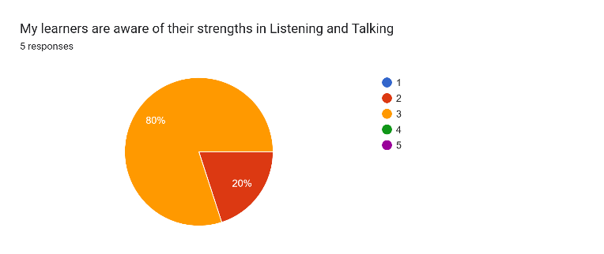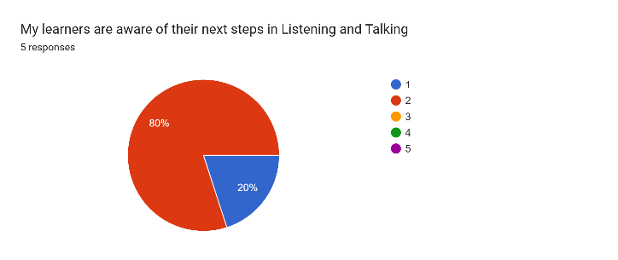

As a result, Listening and Talking Criteria was created and implemented in line with ALP measures across the school to support progression, moderation and high-quality learning and teaching. Teachers use the criteria regularly during planning, assessment and in providing feedback to learners, facilitating more focused discussions around strengths and areas for improvement for learners. This also led to greater pupil engagement in self and peer assessment, and improved consistency in approaches to evaluating attainment and achievement across the school. All teachers agree or strongly agree (May 2026) that implemented criteria supports progression, moderation and focused learning and teaching, enabling children to make progress in their learning.
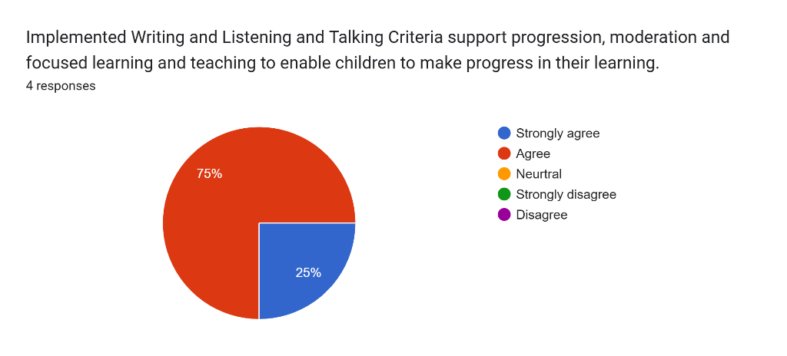
The Listening and Talking criteria has also supported self and peer-assessment, enabling children to identify their strengths and areas for development, and create their own personalised targets. This has encouraged greater learner ownership of progress, increased engagement with the learning process and helped children to develop a clearer understanding of the skills and success criteria required to improve their Listening and Talking abilities. In a Pupil Council Group survey completed in June 2026, most children identified that they know their strengths and next steps in Listening and Talking.
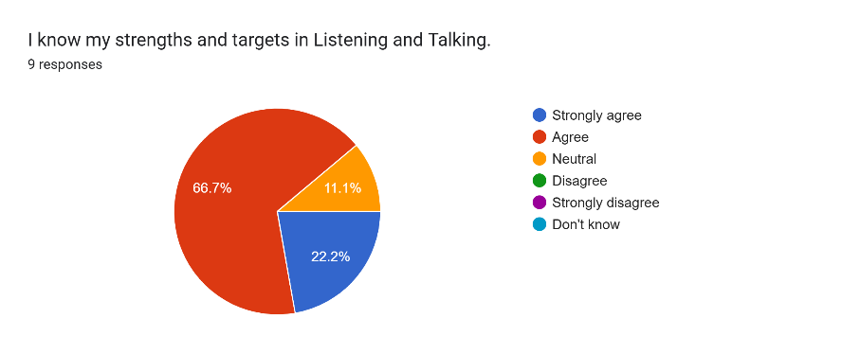
As part of our mini-cluster moderation programme, staff were organised into working groups across Early, First and Second Level. Working collaboratively with colleagues from partner schools, teachers participated in two half-day In-Service moderation sessions focused on Listening and Talking. These sessions were facilitated by the cluster QAMSOs and provided valuable opportunities for professional dialogue, moderation of evidence and the development of a shared understanding of Curriculum for Excellence Benchmarks and standards. Miss Kirsty Robertson, Acting Principal Teacher, fulfils the role of QAMSO in our school and supported staff engagement with the moderation process.
Staff working groups created a series of lessons based on bundled Es and Os, collaboratively planning high-quality learning experiences. Careful consideration was given to the Authority Learning, Teaching and Assessment policy, and an appropriate timeframe for the delivery of these lessons was agreed across the group.
Following the initial planning session, staff delivered a minimum of three to four lessons and gathered a range of relevant assessment evidence, including observations, learner dialogue, self and peer assessment, and teacher professional judgement. This evidence was then brought back to a second moderation session where colleagues engaged in professional discussion to evaluate learners' progress against the agreed benchmarks and standards. This process strengthened the reliability of assessment judgements, promoted greater consistency across schools and supported a shared understanding of achievement within Listening and Talking.
Listening and Talking CLPL was delivered throughout the session, both from Literacy Cluster Lead Laura Johnstone and through targeted collegiate sessions delivered by the Head Teacher. These sessions revisited the pedagogical foundations of Listening and Talking, explored the current educational context, including equity considerations, and highlighted the characteristics of highly effective practice. Staff used self-evaluation activities to reflect on current approaches and identify areas for development.
Professional learning also focused on breaking down Listening and Talking into discrete skills, providing practical strategies to teach and assess listening, support exploratory talk and develop effective group discussion skills. Further sessions explored approaches to raising the quality of learner talk across Early, First and Second Level, alongside guidance on assessment and the application of Curriculum for Excellence Benchmarks.
As a result, staff developed a deeper understanding of progression within Listening and Talking and increased their confidence in planning, delivering and assessing high-quality learning experiences. The professional learning complemented cluster moderation activities, supporting greater consistency in teacher professional judgement and a shared understanding of standards across the school and cluster. All Teachers indicated that they are now confident in their understanding of the progression of Listening and Talking Skills within their stage in the school and all use a range of resources/technology to support this (May 2026).
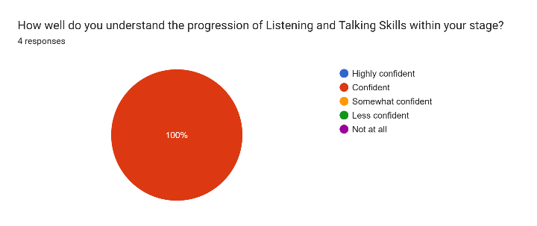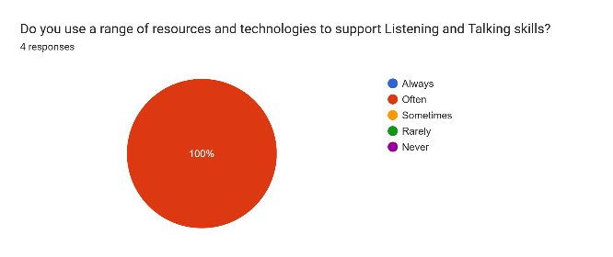
As a result of cluster work on Listening and Talking this session, all staff agree or strongly agree that there is a shared understanding of standards across the cluster as a result of the work undertaken through this priority as outlined below (June 2026).
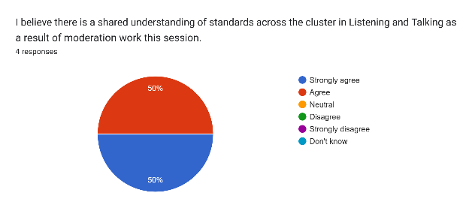
As a result of cluster work on Listening and Talking this session, our attainment is as below (May 2026) –

P1 – 90% of all learners on track or exceeding in listening and talking
P2 – 100% of all learners on track or exceeding in listening and talking
P3 – 77% of all learners on track or exceeding in listening and talking
P4 – 75% of all learners on track or exceeding in listening and talking
P5 – 87% of all learners on track or exceeding in listening and talking
P6 – 89% of all learners on track or exceeding in listening and talking
P7 – 67% of all learners on track or exceeding in listening and talking

Across the school, 82% of all learners are on track or exceeding in listening and talking.
All learners in P1 and P2 have demonstrated increased attainment by 1 or more XBRA levels this session in Listening and Talking, as identified through progress and achievement data.
Almost all learners in P3 (92%) have demonstrated increased attainment by 1 or more XBRA levels this session in Listening and Talking, as identified through progress and achievement data.
Most learners in P4 (88%) have demonstrated increased attainment by 1 or more XBRA levels this session in Listening and Talking, as identified through progress and achievement data.
Most learners in P5 (87%) have demonstrated increased attainment by 1 or more XBRA levels this session in Listening and Talking, as identified through progress and achievement data.
Most learners in P6 (89%) have demonstrated increased attainment by 1 or more XBRA levels this session in Listening and Talking, as identified through progress and achievement data.
Most learners in P7 (89%) have demonstrated increased attainment by 1 or more XBRA levels this session in Listening and Talking, as identified through progress and achievement data.

As a result, 92% of all learners have made at least one XBRA level of progress in Listening and Talking by June 2026, tracked through school data and cluster moderation, we achieved the target set in August of 90%.
All Teachers agree or strongly agree that there have been a variety of opportunities provided in school to develop children’s listening and talking skills as identified below (May 2026).
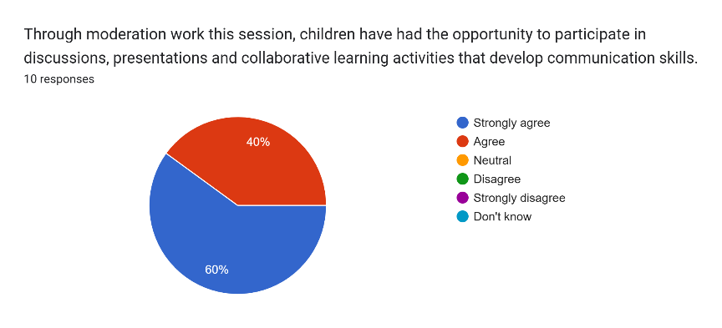
Quality assurance observations, peer observations and self-evaluation evidence of Listening and Talking lessons indicates that there are improved pedagogical practices and confidence in assessing Listening and Talking for all teachers. Teachers demonstrated a greater understanding of progression within Listening and Talking, more effective use of success criteria and assessment evidence, and increased consistency in professional judgement, as identified during Tracking and Monitoring conversations with the Head Teacher. As a result, learners experienced more structured opportunities to develop and apply their Listening and Talking skills, were better able to reflect on their own progress through self and peer assessment opportunities, demonstrating increased confidence and progression of skills when participating in discussions, presentations and collaborative learning activities, as identified in completed Listening and Talking assessment criteria as indicated in Teacher surveys below (June 2026).
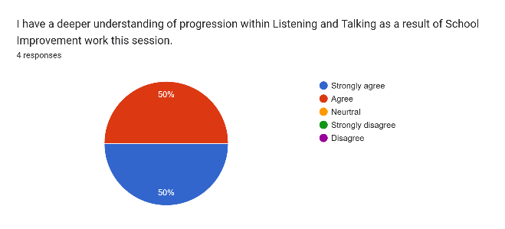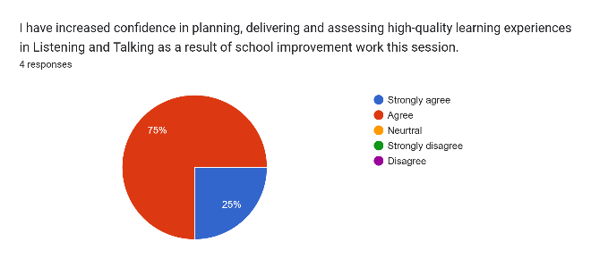
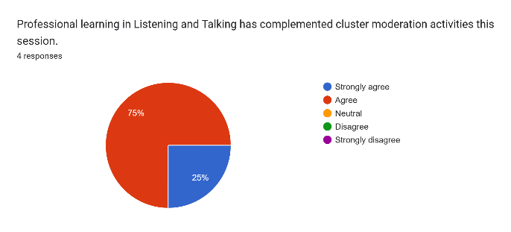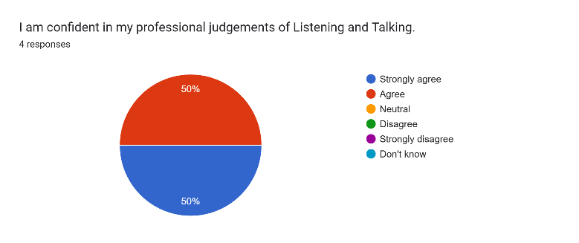

Parents report increased confidence in their child’s listening and talking development as indicated through a parent survey in May 2026 as indicated below.

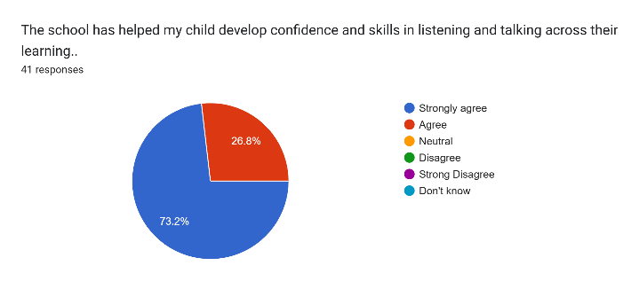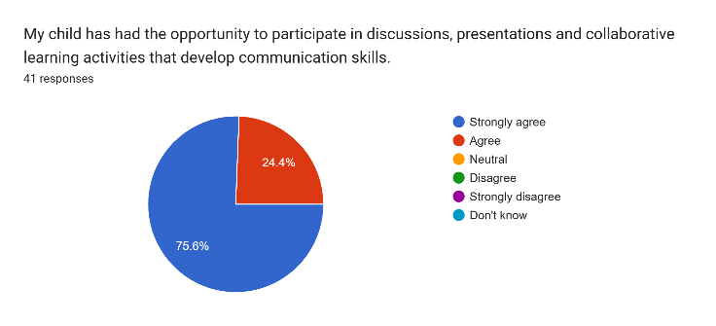
Next Steps:
- Staff to continue to engage in moderation across the cluster, through another identified curricular area
- The school will continue to develop in house approaches to moderation across other organisers
- The school will continue to seek opportunities to involve parents in learning sessions to support their child’s development of knowledge and skills, out with the school environment
Review of SIP | Priority 3
Raise attainment and achievement for our most vulnerable learners through improved approaches to wellbeing and inclusion.
Progress and Impact:

Our school Positive Relationships Policy was reviewed, renewed and further embedded this session, ensuring a consistent and shared approach to promoting positive behaviour and relationships. A key strength of this process was the meaningful involvement of partners, including staff, pupils and parents/carers, which supported a shared understanding and ownership of the policy.

As a result, there is now a clearer and more consistent approach to promoting positive relationships across the school. Pupil voice indicates a strong understanding of the school's values and expectations, alongside an increased sense of belonging and positive engagement in school life. This is further reflected in children's overall wellbeing, as evidenced by data from the Glasgow Motivation and Wellbeing Profile gathered in March 2026 and June 2026. Across the 28 wellbeing comparators, 27 showed improvement over this period, indicating positive progress in learners' perceptions of their wellbeing, relationships, engagement and experiences within school. These findings suggest that the school's focus on positive relationships and wellbeing is having a measurable impact on pupils' experiences and outcomes.
P1
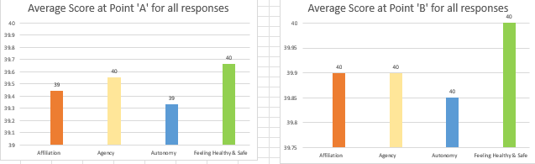
P2
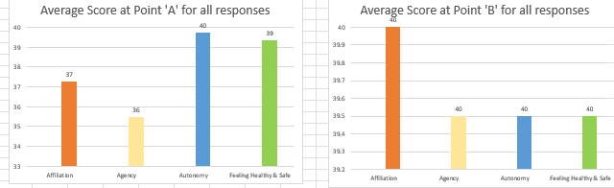
P3
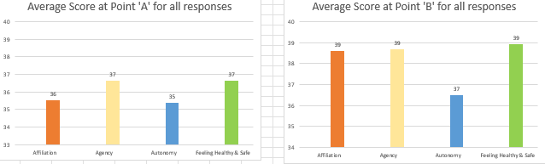
P4
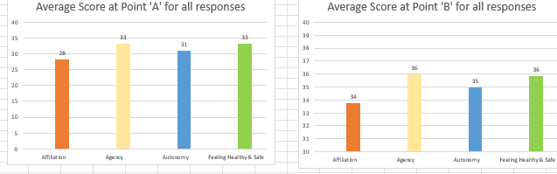
P5
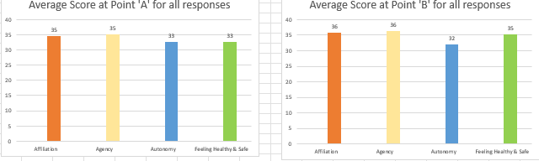
P6
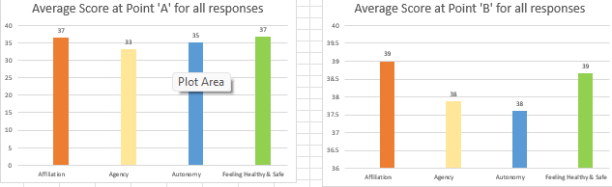
P7
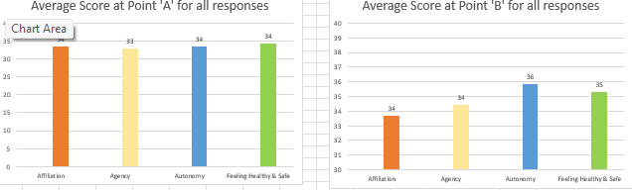

Engagement with parents/carers also strengthened communication and reinforced shared expectations between home and school. Feedback gathered from parents/carers in May 2026 indicates that almost all parents/carers believe that the school policy promotes positive relationships.
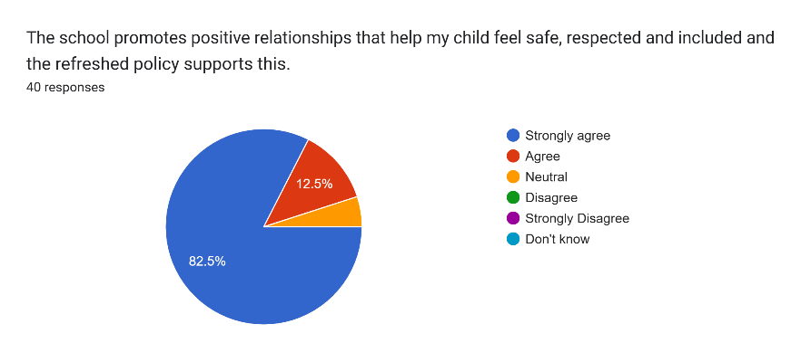
All staff strongly agree that the school promotes positive relationships, supported by the refreshed school policy (May 2026).
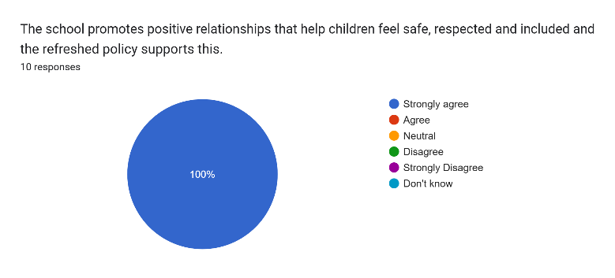
This session, personalised support plans were developed for learners identified as Stage 1–3 of the Staged Intervention process to ensure appropriate support and targeted intervention. This approach strengthened the school’s capacity to respond to individual learner needs in a more structured and consistent way.

An initial audit was undertaken to identify learners requiring personalised support, ensuring that interventions were accurately targeted and appropriately matched to need. The involvement of learners, parents/carers and partners in target setting further enhanced ownership of learning and supported more meaningful engagement with identified next steps.

Tracking and Monitoring meetings with the Head Teacher identified learners who are not on track with their learning. This was then discussed with the ASN Co-ordinator, who works collaboratively with Class Teachers and Support Staff to plan and implement appropriate interventions and support strategies. This joined up approach ensures that provision is well targeted, responsive and aligned to individual learner needs.

As a result, there is improved consistency in the identification and support of learners requiring additional help, with clearer communication and shared responsibility across staff. This has contributed to more timely interventions, strengthened partnership working and a more coordinated approach to supporting learners who are not on track with their learning.

With support from the Senior Leadership Team, staff (teachers and support staff) demonstrated increasing clarity in planning and delivering targeted support, with learners benefiting from more tailored approaches to addressing barriers to learning. This has contributed to improved consistency in the use of staged intervention processes and strengthened the school’s overall approach to inclusion and meeting the needs of all learners.

All learners identified through the staged intervention process have termly SMART targets which are reviewed and evaluated through a collaborative process involving pupils, staff, parents/carers and, where appropriate, partner agencies. This consistent approach has strengthened shared understanding of learner progress and ensured that target setting is more meaningful, focused and responsive to individual needs. Gathered Pupil Council Group survey data indicates that most children feel children in our school get the support they need and engage in conversations with adults about their next steps in learning (June 2026).

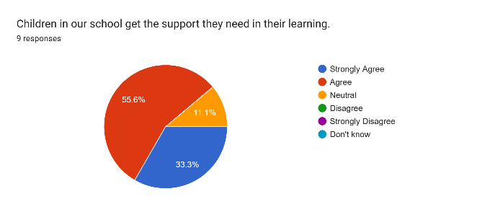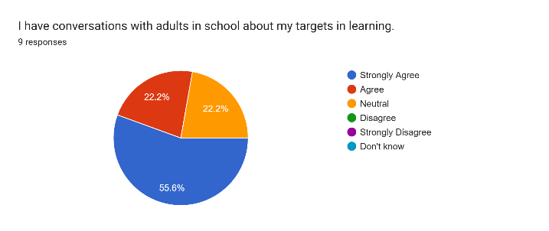

For learners identified as Stage 2 and Stage 3 of the Staged Intervention process, termly Child Planning Meetings provide a structured opportunity for more in-depth review and planning. These meetings support a coordinated approach to identifying barriers to learning, agreeing appropriate interventions and setting clear, achievable next steps. Pupil voice is always heard during Child Planning Meetings and recorded on shared minutes.

As a result of these robust processes, there is increased consistency in tracking and reviewing learner progress, with stronger partnership working supporting more effective planning and intervention. Learners are more actively involved in understanding and working towards their targets, contributing to improved engagement and a more personalised approach to supporting progress and attainment.

All parents/carers surveyed in May 2026 either agree or strongly agree that the school’s approaches to wellbeing and inclusion help all children to achieve success.
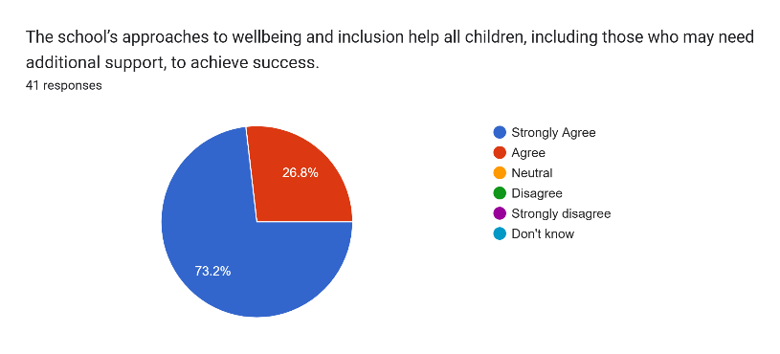

All staff agree or strongly agree with this too as indicated below (May 2026).
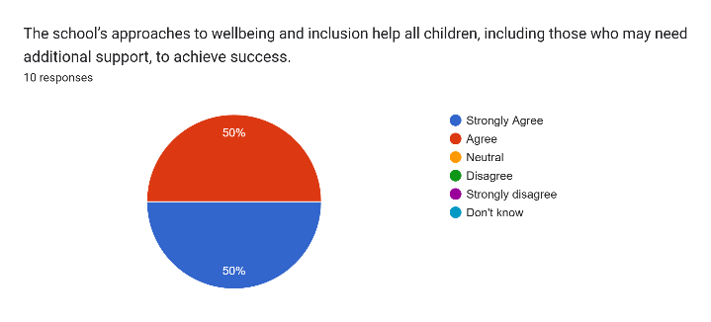

All parents strongly agree or agree that the school works in partnership to support children’s wellbeing, attendance, attainment and achievement (May 2026).
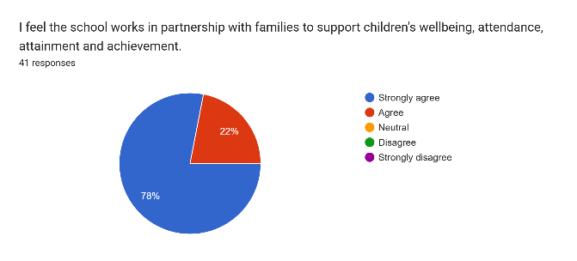

All staff also agree or strongly agree with this statement (May 2026).

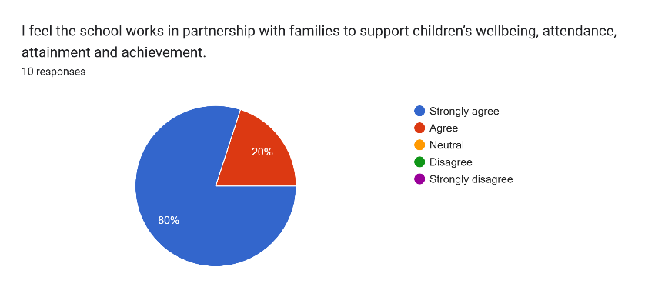

Our school has engaged positively with the OCTF – Thriving Together document. This features in school letters, newsletters and is discussed at weekly assemblies. Learners have contributed to a whole school/ELC floorbook which evidences how the five principles of OCTF - Thriving Together are embedded in the learning and experiences provided for all children at Garelochhead Primary School. Children also receive weekly certificates at assembly from SLT where children have been successful in exemplifying one of the five priority areas. Both certificates and sample pictures from our floorbook have been uploaded to the digital sharing site.

We also have an OCTF display in our entrance hall. Below is a QR code where our children share what this means for them in our school.

Next Steps:

- Continue to track GMWP data each term and meet with children to discuss scores of 5 or below
- Continue to gather wider achievement and subject data
- Continue to promote engagement of OCTF – Thriving Together within the school community
- Revamp pupil of the week certificates
- Work towards achieving RRS Gold and OCTNE Silver in session 26-27

Review of SIP | ELC Priority
Improve curriculum, pedagogy and learner voice through staff understanding
Progress and Impact:
Improve Curriculum, Pedagogy and Learner Voice

Throughout this session, we have strengthened our understanding of the unique context of our school community through a range of approaches. Community walks, outdoor learning beyond the school grounds, local visits to shops, post office etc and the development of a local area display within the learning environment has supported staff and children to explore and celebrate the community in which they live. Children's views have been gathered regularly and have informed planning and decision making through the use of floor books, planning documentation and individual care plans. Information from care plans, parent stay-and-play sessions, SIMD data and census information have enhanced staff understanding of the diverse needs, experiences and strengths of our families. In addition, partnership working with local community organisations such as Oasis Day Care Centre, Centre 81 and through strengthened connections in the school has supported the nursery in making connections between learning and the wider community. As a result, staff have a deeper understanding of the school context and are better placed to plan responsive, relevant learning experiences and targeted support that meet the needs of all learners and families. This has had a positive impact on our children as they are more aware of their surroundings and there is a promotion of environmental understanding, a sense of belonging and community.

All parents surveyed in May 2026 agree or strongly agree that staff have a clear understanding of our local community and use this to support children’s development as indicated below.

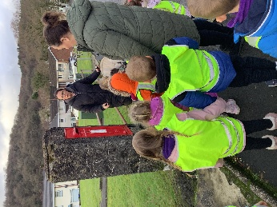
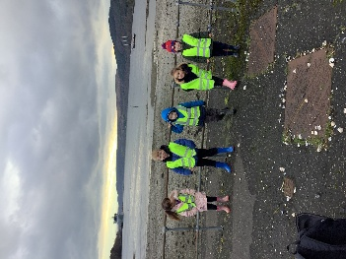
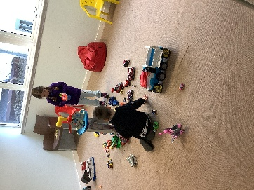
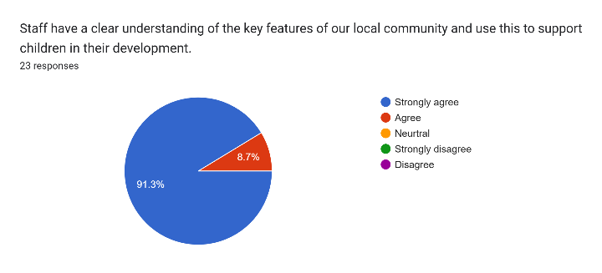

All staff have a focused area of leadership, using this to drive forward improvements that are relevant to the context of Garelochhead including parental engagement and involvement, literacy and communication, community and outdoors, wellbeing, nurture and inclusion. This has strengthened collective ownership of nursery improvement and developed leadership capacity across the staff team. This distributed leadership approach has increased staff confidence and accountability, promoted collaboration and professional dialogue, and enabled a wider range of expertise to influence school improvement. As a result, initiatives have been more responsive to the needs of learners and families, contributing to enhanced learning experiences, stronger partnerships and improved outcomes across the school community. All parents strongly agree or agree that staff contribute to a culture of improvement in the nursery (May 2026) as indicated below.


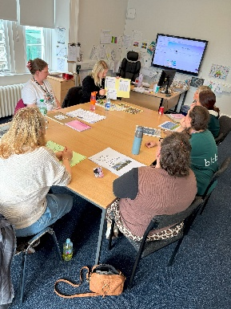
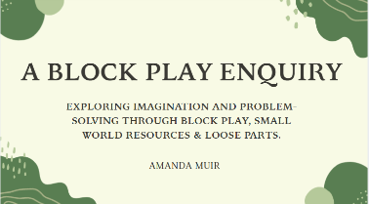
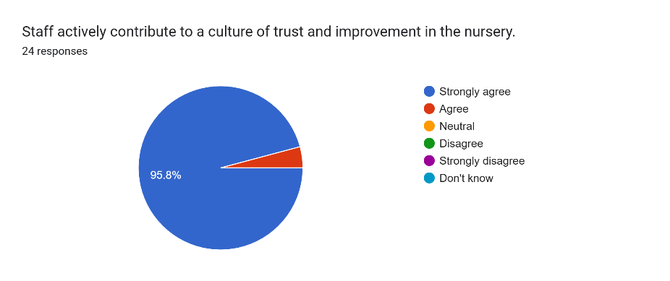

Throughout this session, we have successfully built on existing practice in relation to staff sharing expertise and leading improvement. Partnership working with a local cluster nursery provided valuable opportunities for staff to share and discuss effective practice, fostering professional collaboration and strengthening relationships across settings. All practitioners engaged in professional enquiry and research, developing their knowledge, skills and confidence through a lens of enquiry focused on identified leadership areas. Opportunities to share experiences, to work collegiately during meeting nights and In-Service Days, to discuss findings and explore new approaches generated professional dialogue and inspired further ideas for development within the team. This has supported a culture of continuous improvement, where staff feel empowered to contribute to change and innovation.

Regular self-evaluation activities have enabled staff to critically reflect on their practice, identify strengths and areas for development, and implement improvements in ways that are meaningful to their individual roles and the needs of the setting. The use of Quality Indicator Framework challenge questions and collegiate sessions has further strengthened professional reflection, leading to deeper evaluation of interactions, experiences and learning spaces. As a result, staff have increased confidence in leading and sharing practice, there is greater consistency in reflective approaches across the team, and improvements are increasingly informed by evidence, professional enquiry and collaborative learning. This has enhanced the quality of experiences and environments for children and strengthened the nursery's capacity for ongoing improvement.

Literacy and Numeracy

Practitioners have effectively implemented Literacy and Numeracy Progression Frameworks to support the planning, delivery and pacing of Experiences and Outcomes throughout the nursery. This has provided greater clarity and consistency in curriculum delivery, ensuring children experience a progressive and coherent learning journey that is responsive to their individual stages of development and learning needs.

This session, we reviewed and refined our planning processes to ensure they were more responsive to children's interests, needs and next steps. New weekly, area planning formats were introduced, placing a greater emphasis on learner voice, ensuring that children's ideas, questions and interests are reflected in planned experiences. We also refreshed our long-term planning format to strengthen progression, breadth and coverage across the curriculum while maintaining flexibility to respond to emerging learning opportunities. All staff agree or strongly agree that learners are now more involved in planning and leading the learning in the nursery (May 2026).

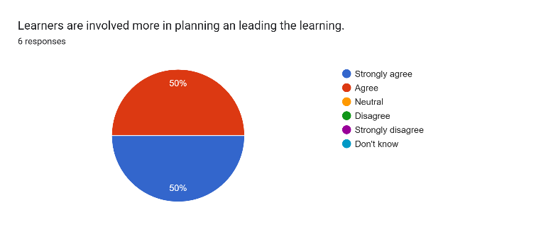

All parents agree/strongly agree that their child has opportunities to lead learning and make choices throughout the nursery day (May 2026).

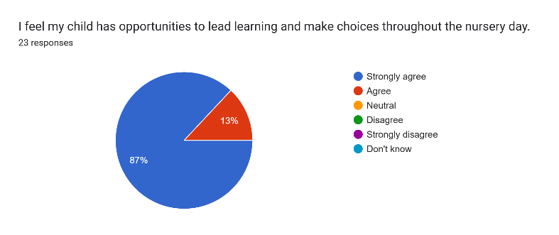

To further support effective tracking and monitoring, Learner Journeys were introduced for all children. These provide a clear overview of children's progress, achievements and experiences across the curriculum and support practitioners in identifying gaps in learning and planning appropriate next steps. The use of Learner Journeys has strengthened practitioners' understanding of individual children's progress through the Experiences and Outcomes and has improved the quality of evidence available to support professional judgements. As a result, practitioners have greater confidence in planning for progression, tracking learning and demonstrating children's achievements. The improved planning and tracking processes have enabled more focused professional discussions, enhanced the consistency of assessment approaches and ensured that learning experiences are increasingly tailored to meet the needs, interests and developmental stages of all children. Almost all parents agree/strongly agree that they have a good understanding of their child’s progress in Literacy and Numeracy/Mathematics as indicated below. They also feel that Learner Journeys are an effective way of demonstrating their child’s individual progress in learning (May 2026)

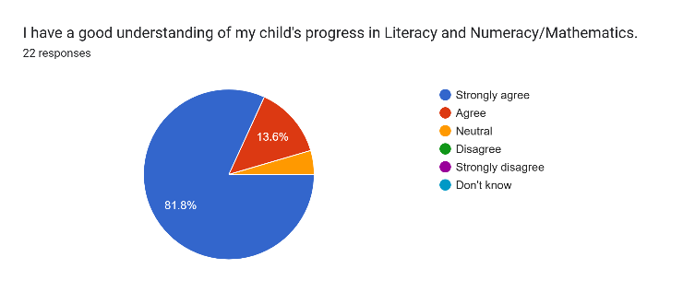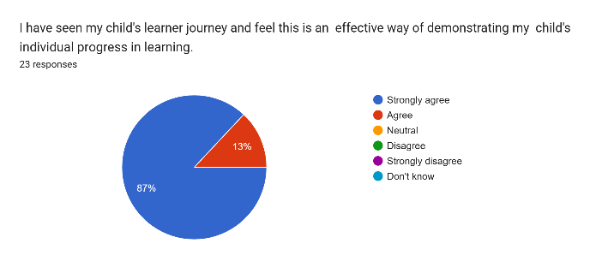

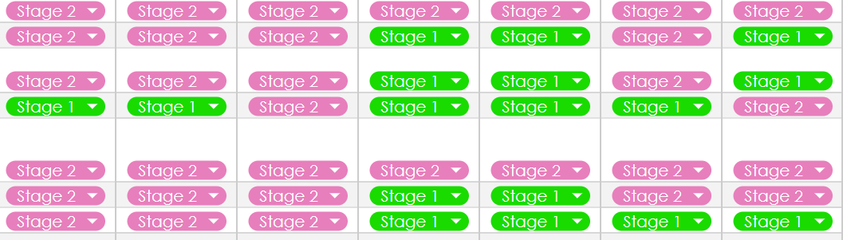
Practitioners have developed increasing confidence in tracking and monitoring children's progress through regular observations, assessment evidence and professional dialogue. The use of progression frameworks has strengthened practitioners' understanding of progression and achievement, enabling them to identify next steps in learning more effectively and plan targeted experiences to support individual needs. Robust evidence gathered through observations, learning stories, floor books and assessment records has improved the quality and consistency of professional judgements. As a result, practitioners are better able to demonstrate children's progress and achievement, providing a clearer picture of attainment over time, as has been evident in termly Tracking and Monitoring conversations with the Head Teacher and Lead Practitioner. This has enhanced moderation discussions and strengthened confidence in reporting on children's learning and development. Staff now have a clearer understanding of individual progress, and this supports early intervention, support and challenge, as is required for example through individual targeted groups such as in listening and talking. Evidence of this is provided below which demonstrates that a number of our pupils are exceeding in Literacy and Numeracy organisers (purple) or on track (green). Most of our pupils (N4-N6) are on track with all Developmental Milestones.

Developmental Milestones Data -

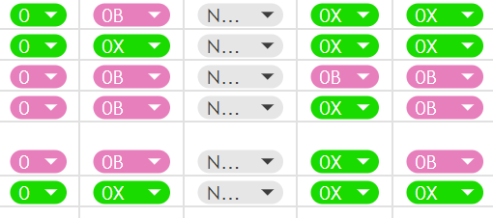
XBRA Data

The majority of our pupils (N5-N6) are on track with all Literacy and Numeracy organisers.

Practitioners have worked collaboratively to develop a more robust and consistent approach to observation, strengthening their confidence in using observations to support high quality interactions, assess children's development and inform planning. Through professional dialogue, self-evaluation and shared reflection, staff explored the different purposes of observation and considered the most effective approaches for gathering meaningful information about children's learning, engagement and progress.

Termly Leuven Observations have been introduced for all pupils, both in the morning and afternoon to provide a deeper understanding of children's levels of wellbeing and involvement across different contexts and times of the day. This has enabled practitioners to identify patterns in engagement, evaluate the impact of the learning environment and interactions, and make informed decisions about planning and provision.

Staff benefit from the use of meeting nights to moderate observations, ensuring consistency and accuracy of scoring, strengthening shared understanding of wellbeing and involvement indicators. These moderation discussions also provide valuable opportunities for professional dialogue, allowing staff to share practice, reflect on evidence, and make informed suggestions for improving interactions, learning experiences and the organisation of the environment. As a result, observation practice is more consistent and reliable, and there is a stronger collective approach to using evidence to inform improvement and enhance outcomes for children.
The use of Leuven Observations has strengthened practitioners' understanding of children's individual needs and experiences, supporting more targeted interventions leading to improvements in learning spaces, routines, experiences and interactions. An example of improvement in wellbeing and involvement for four of our pupils is identified below.
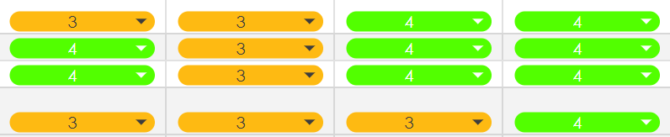

We have also used environmental Leuven Observations to ensure our environments are fit for purpose, tracking children’s levels of engagement and involvement, using this information to make informed changes to the learning environment. This has supported practitioners to evaluate how effectively spaces, resources and routines are meeting children’s needs and interests. As a result, adaptations have been made to improve flow, accessibility, challenge and opportunities for deeper learning, for example, our home corner has now been moved to a quieter space in the nursery and is now accessed more regularly by children throughout the nursery day. This ongoing cycle of observation, reflection and adjustment has ensured that the whole nursery environment (indoors and outdoors) is more responsive, purposeful and engaging, leading to increased levels of wellbeing, involvement and sustained play for learners.

The increased focus on observation has enhanced practitioners' ability to identify children's interests, strengths and next steps, leading to more responsive planning and higher-quality interactions. Observations are now used more effectively to inform assessment, track progress and support professional judgement, ensuring that decisions are based on robust evidence of children's learning. As a result, staff have developed greater confidence and skill in carrying out observations for a range of purposes and all staff agree or strongly agree that we have a robust system of observation which provides a better understanding of children’s interactions, engagement and development as a result of this (May 2026).

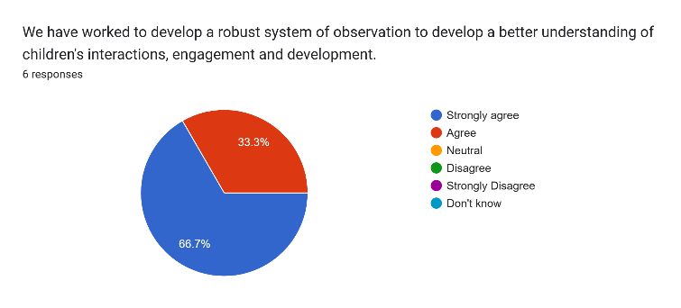
Children participate in local walks in and around Garelochhead to encourage a sense of familiarity and belonging around the local community. Children regularly visit Centre 81 where they participate in community experiences both indoors and outdoors, visits to The Oasis Daycare Centre where they build multigenerational relationships. Our community walks are linked to children’s interests and are meaningfully planned to reflect this. PLPs highlight how practitioners used family knowledge to plan meaningful experiences and strengthen children’s sense of belonging within the Garelochhead and Helensburgh community.

Floor Books capture and collate the voice of learners as they develop in the setting through the year
Practitioners use Floor Books to record children’s ideas, interests, achievements, experiences and learning journeys through photographs, observations, conversations and children’s marks.
The Floor Books demonstrate how practitioners listen to and value children’s voices, using their interests and curiosity to influence responsive planning and next steps in learning. They provide clear evidence of progression, participation and engagement across the curriculum.
Floor books include children’s voice, photographs and evaluations from these experiences. Practitioners recorded how children developed confidence, communication and awareness of the wider community. Practitioners also use Floor Books to reflect children’s connections with their families and the wider Garelochhead and Helensburgh community. Experiences such as local walks, visits to parks and beaches, community events and discussions are documented to show meaningful, real-life learning opportunities.
Children regularly revisit Floor Books to recall previous experiences, share achievements with peers and families, and contribute new ideas for future learning. This supports children to develop confidence, communication skills, a sense of belonging and ownership of their learning within the nursery setting as is reflected by most staff below (May 2026).
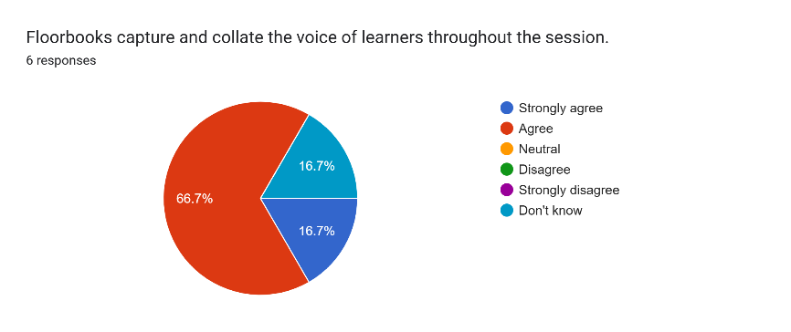
Almost all parents/carers share that they have had the opportunity to look through ELC Floor Books this session which showcases children’s learning experiences, achievements, interests and progress.
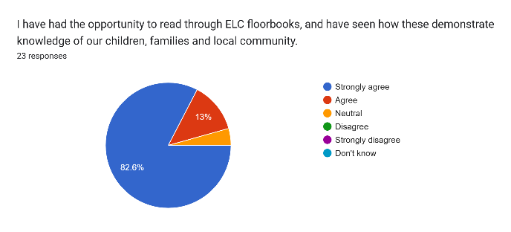
Next Steps:
- Staff to refamiliarise themselves with Realising the Ambition through a monthly Book Group
- Staff to continue with leadership roles to promote positive leadership development through the lens of enquiry and in collaboration with another setting
- Continue to develop approaches to self-evaluation to improve the setting
- Embed UNCRC and the Rights of the Child with families
- Introduce Argyll and Bute’s Counting on Excellence Framework to further strengthen experiences provided in the nursery related to Numeracy and Mathematics
- Create richer literacy and numeracy environments throughout the setting
- Continue to develop and improve staff knowledge and understanding of schematic play
- Improve peer moderation process within the setting

1.1 Attainment Data
Attainment of Literacy Curriculum for Excellence levels 2021/22, 2022/23, 2023/24, 2024-2025 and 2025/2026 (teacher judgement – confirmed levels – 5 year trend).
READING
WRITING
TALKING AND LISTENING

Please Note:
The above data (1.1) reports achievement of a level – P1/P4/P7 combined.

1.2 Attainment Data
Attainment of Numeracy Curriculum for Excellence levels 2021/22, 2022/23, 2023/24, 2024-2025 and 2025/2026 (teacher judgement – confirmed levels – 5 year trend).
NUMERACY

Please Note:
The above data (1.2) reports achievement of a level – P1/P4/P7 combined.

Wider achievements
- What opportunities for wider achievement were offered?
- What systems are in place to track and monitor participation?
- How have you addressed any gaps in participation?
At Garelochhead Primary School and Primary ELC, we increasingly recognise and value young people's achievements and development of skills, including opportunities for learning in the Community. Participation in experiences inside and outside of school offer pupils’ opportunities for personal learning and achievement across a broad range of activities.

Personal Achievements
Personal achievements are collated monthly then celebrated in whole school assemblies. Our personal achievements display links children’s achievements to the relevant meta-skills. A ‘Seesaw’ online portfolio celebration class continues to be accessed by all classes to record achievements and track experiences shared from out with school. A total of 27 achievements were shared by parents, carers or children themselves between November and May 2026, displayed on our wider achievements display.
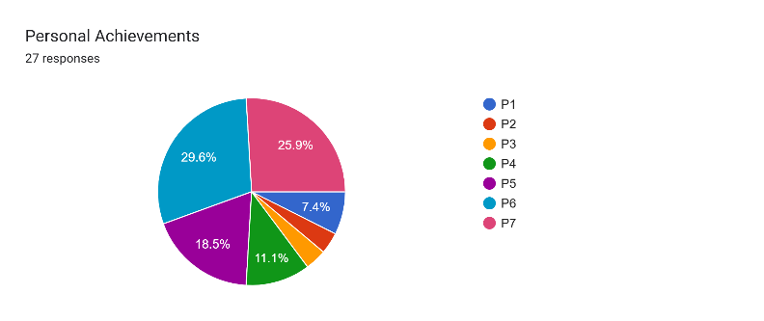
The Head Teacher meets with children termly to discuss wider achievements. A further 39 achievements were shared by children in Terms 2 and 3 this session (by May 26).
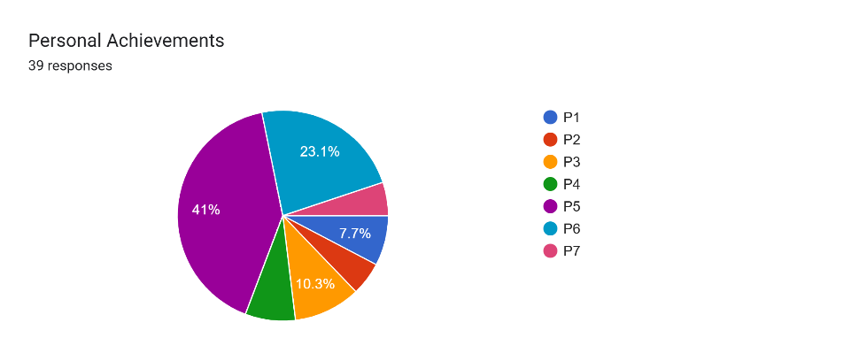
Community Events, Charity and Sporting Events
A number of pupils from P4 - P7 have taken part in community sporting events throughout the year:
- Christian Aid Football - Mixed
- Girls’ Christian Aid Football Festival
- Helensburgh Tennis Club Inter-Schools Tournament
- P6 and P7 Cross Country
- Day of Dance
Pupils are selected for these events by teaching staff and support staff, with particular acknowledgement given to pupils who haven’t previously had an opportunity, are unable to participate in other wider school activities or those who are part of our targeted groups. Pupils have demonstrated dedication to improving their skills through regular attendance at after school clubs and community provision. All P6 and P7 pupils are invited to participate in the P6 and P7 Cross Country event, as organised by Live Argyll, Active Schools.
Facilitated by Helensburgh and Lomond Rotary Club, MOD Community Police and Police Scotland Community Engagement Officer, all pupils in P4 - P7 engaged in Internet Safety sessions. Children were invited to share key internet safety messages through participation in an annual competition. A P6 and P7 pupil were both highly commended during the awards ceremony at Helensburgh Civic Centre.
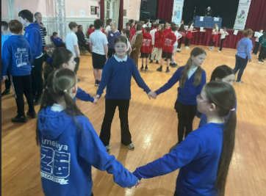 | 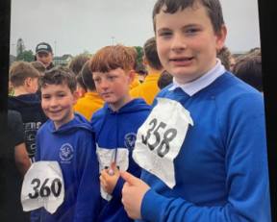 | 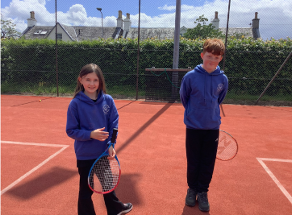 | 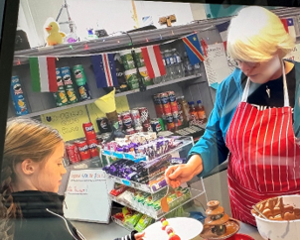

After School Club Provision
This session, we provided a block of after school clubs in the summer term. Clubs offered include: Outdoor Adventure, Gardening, Netball and Construction Club.
Due to support from the local community and a parent helper, we were also able to provide a Karate Club, a Pathfinders (Scripture Union) club and a Football After School Club.
Garelochhead data is submitted to the Scottish Government as a contribution to the tracking and monitoring of physical activity in Primary Schools.

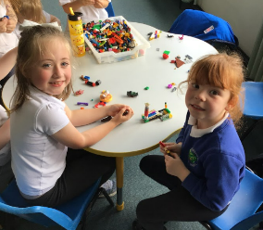 | 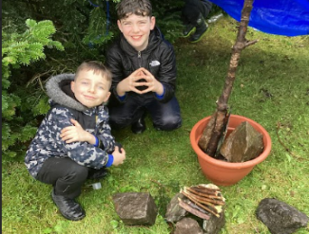 | 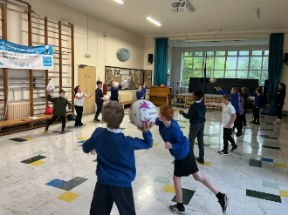 | 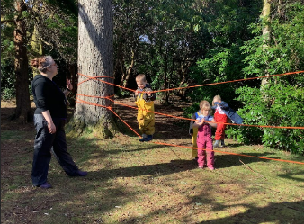

Lunchtime Club Provision
This session, we introduced weekly lunchtime clubs to provide all pupils with the opportunity to participate in a wider range of experiences that extend learning beyond the classroom, led by our highly skilled support staff team. Clubs offered include Art, Construction and Board Games. This has evolved in the better weather in Term 3 by all clubs being offered on a daily basis in the playground, contributing to improved engagement, wellbeing and increased opportunities for scaffolded social interaction, building positive relationships in the school community.

Young Carers
The school has strong links and partnerships with key community supports including Helensburgh and Lomond Young Carers. Helensburgh and Lomond Young Carers provided an assembly for the school on Young Carers Action Day this session which saw an increase of 60% in the number of our pupils who identify as a Young Carer. A Young Carers Lunchtime Club has been introduced, led by our Clerical Assistant who is our Young Carer’s Champion. A sample of some of the work undertaken is shared below.
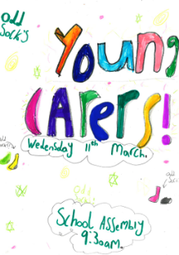
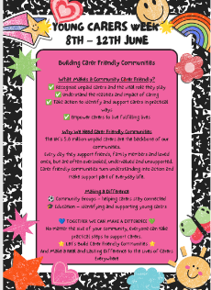

Assembly Certificates
Throughout the academic session, staff throughout the school award pupils (one from each year group) for being Pupil of the Week. Reasons given extend beyond that of academic achievement, often recognising a child’s contributions to the wider ethos of the school and community.

Certificates are also provided to one pupil in each class for demonstrating positive behaviours and achievements, with a clear focus on recognising and promoting children’s rights. This includes pupils who consistently demonstrate respect for others, uphold the rights of their peers and contribute positively to the wider school ethos.

This session we introduced Our Children Their Future – Thriving Together certificates, awarded by SLT to pupils and staff who demonstrate achievement that reflect our school and Authority values, related to the 5 key priority areas – Nurtured Learners, Best Start for Learners, Ambitious Learners, Connected Learners and Lifelong Learners. This is an example of the certificate pupils receive –
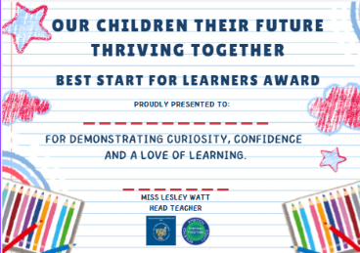

Monthly Newsletters
Monthly newsletters provide the opportunity for staff to share with parents/carers key information about wider achievement opportunities within the school, celebrating pupil and class successes whilst highlighting ongoing learning across the school. Our May 26 newsletter can be found here.

Going for Gold - Rights Respecting School

Following our success last session when we were awarded our Silver Rights Respecting Schools Award, we continue to work towards achievement of Gold. Miss Kirsty Robertson (Acting Principal Teacher) co-ordinates this development. Throughout the year, Garelochhead Guardians have led the next phase of our Rights Respecting School’s journey by sharing and celebrating our Silver Award achievements with the wider school community, reviewing and expanding the steering group to ensure representation from all classes and supporting staff and learners to understand the increased expectations of Gold accreditation. The group has used recommendations from the Silver accreditation report to inform an initial action plan focused on broadening understanding of children’s rights, strengthening pupil participation and leadership, as well as embedding global citizenship, sustainability and equality across the curriculum and wider life of the school.
We are working towards achievement of Gold Rights Respecting Schools status in Term 3 of session 2026/2027.
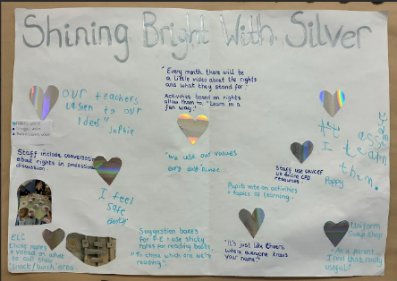 | 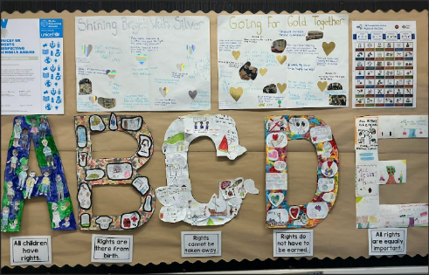 | 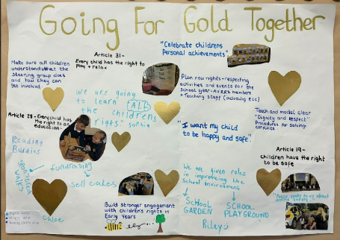

Librarians
Throughout the year, our School Librarians have demonstrated effective leadership through the successful launch of the Lending Library initiative. By creating opportunities for children and families across the school and ELC to access and enjoy books together, they have promoted a positive reading culture and strengthened engagement with Literacy beyond the classroom. Librarians have taken responsibility for planning, promoting and supporting the initiative, making effective use of digital technologies to develop systems for book lending and returns. Through their leadership, organisation and commitment, they have made a valuable contribution to fostering family engagement and encouraging a lifelong love of reading within the school community.

Through a collaborative termly newsletter shared with families and classes, the Librarians keep the school community updated on key changes, champion a tidy and welcoming reading environment and gather inspiration for exciting upcoming events like World Book Day.
Lending Library:
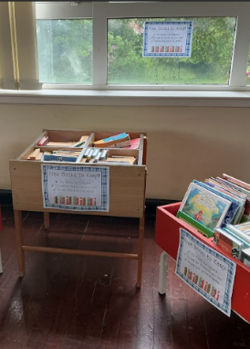 | 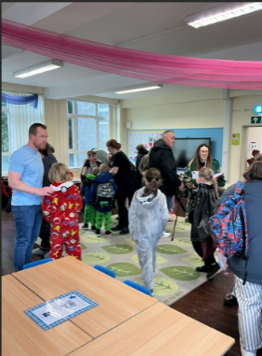 | 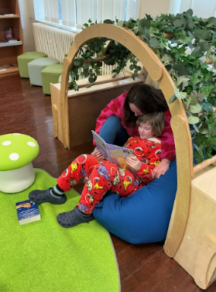 | 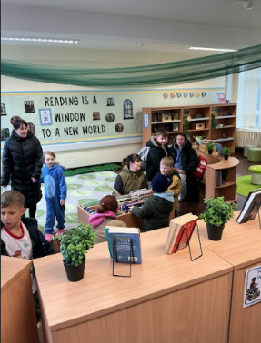 | 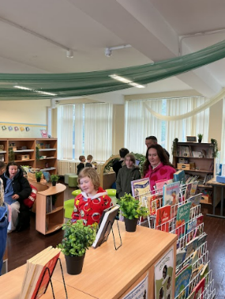

Pupil Council
The Pupil Council has demonstrated effective leadership and influence in school improvement, with children contributing meaningfully to decisions that impact daily school life, including the introduction of systems such as the five-minute playground tidy-up bell. Pupils’ views have been actively sought and considered during the review of the school report card format, reinforcing the importance of learner voice in shaping school decisions. The Pupil Council continues to communicate effectively with the wider school community by sharing updates and pupil perspectives through their termly newsletter to classes, helping to increase visibility and engagement across the school.

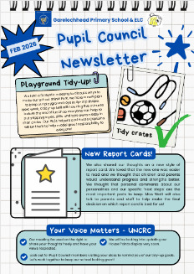 | 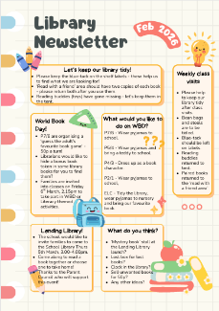

Armed Forces

Forces and Me – Lunchtime Club
During Term 2, Emer Flett (Service Pupil Advisor) co-ordinated a lunchtime club open to all children from a Military Family at Garelochhead Primary School. Children had the opportunity to share their experiences of service life with one other, as well partake in crafts, games and other social opportunities in a relaxed environment, giving an alternative to the normal lunchtime experience. The sessions ended with a party where children were able to bring a friend from a non-forces background with them to support understanding within the community between service and non-service families.

Forces and Me – Wellbeing Sessions
During Term 3, pupils from serving Armed Forces families benefited from an 8 week block of sessions delivered by Jenny Caulfield (Exchange Counselling) which provided targeted emotional and wellbeing support in a safe, supportive and confidential environment. The sessions focused on helping children to explore and manage feelings associated with service life, including transitions, separation, and change, while also developing strategies to build resilience, emotional literacy and coping skills.

Health Week
This session, Mrs Cormack (P7/6) Class Teacher organised a highly successful Health Week in May 2026. Pupils benefited from an action pack week of activities and experiences designed to promote physical health, mental wellbeing and positive lifestyle choices. Activities included a range of sporting events such as karate, athletics, netball delivered by specialists in our local community. Children also experienced additional outdoor learning opportunities, team challenges and workshops focused on healthy eating, wellbeing, mindfulness and resilience. The week provided opportunities for pupils to work collaboratively beyond the classroom environment, develop leadership skills and engage in new experiences that promoted confidence and enjoyment in being active. As a result, pupils demonstrated increased awareness of how to maintain a healthy lifestyle and showed high levels of engagement, motivation and enthusiasm throughout the week.
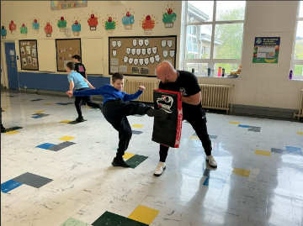 | 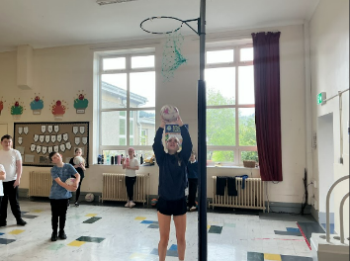 | 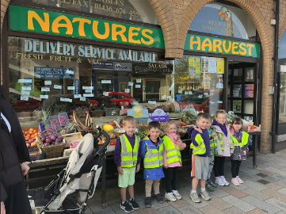 | 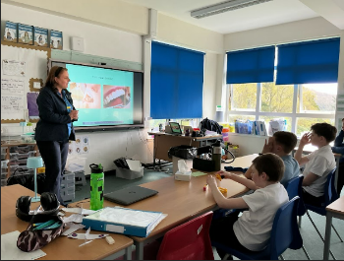

Heartstart
P7/6 welcomed volunteers from Heartstart who delivered the programme, teaching the children what to do in an emergency, how to perform CPR and how to respond confidently and safely in a range of first aid situations. As a result, learners increased their knowledge and understanding of basic first aid and demonstrated responsibility, resilience and confidence in doing so.
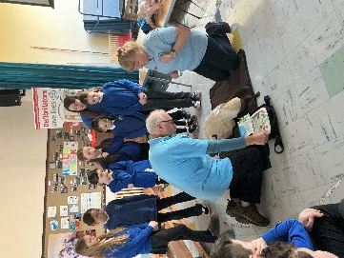 | 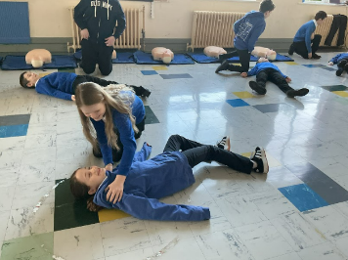 | 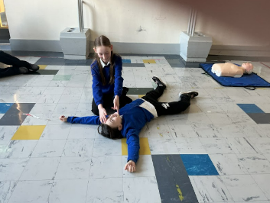 | 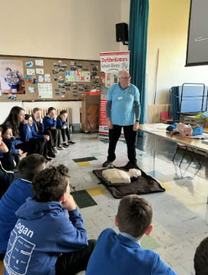

Easter Code/Christmas Unwrapped
As part of their transition experience, P7 pupils have engaged in wider opportunities through the Scripture Union events alongside other cluster schools, participating in Christmas Unwrapped and Easter Code.

P7 pupils explored the Christmas story through ‘Christmas Unwrapped’, working collaboratively with the Scripture Union team and other P7 pupils from cluster schools to complete drama and art activities, which deepened their understanding and reflection whilst enabling them to build relationships with peers.

Christmas Unwrapped:
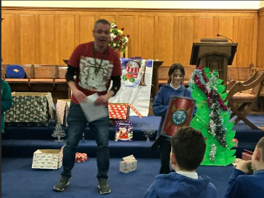 | 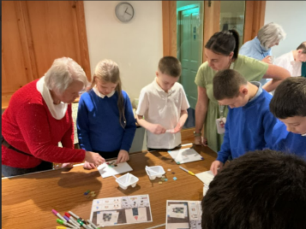 | 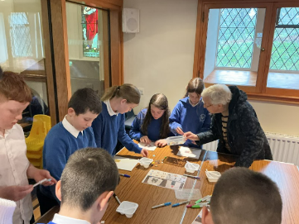 | 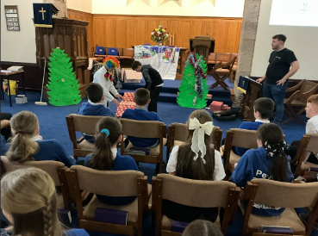

P7 pupils also took part in Easter Code, engaging with volunteers from the local church community to explore the meaning of the Easter story. These experiences supported positive transition by promoting collaboration, creativity and engagement with community partners.

Easter Code:
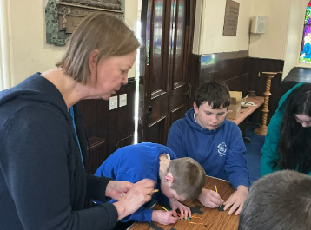 | 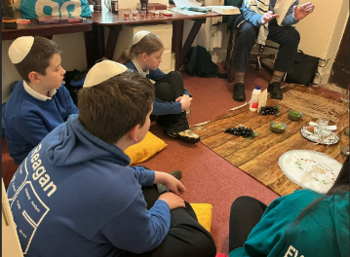 | 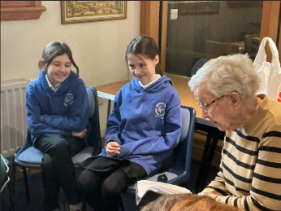 | 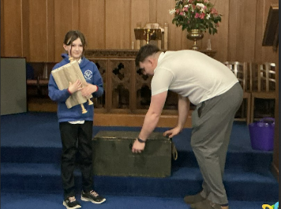

Pupil Equity Funding
Summarise progress and next steps in relation to pupil equity funding.
Progress and Impact:

Our focus areas for PEF spending this session have been:
- Increased attainment in Reading for all target groups
- Increased attainment in Numeracy for all target groups
- Increased attendance and attainment for targeted learners through our Breakfast Club/Walking Bus provision

Reading

P1 – 89% of identified learners, living in Quintiles 2 and 3 are on track or exceeding in reading, this is an increase of 14% when compared with October 2025 data
P2 – 100% of identified learners, living in Quintiles 2 and 3 are on track or exceeding in reading
P3 – 72% of identified learners, living in Quintiles 2 and 3 are on track or exceeding in reading
P4 – 88% of identified learners, living in Quintiles 2 and 3 are on track or exceeding in reading, this is an increase of 2% when compared with October 2025 data
P5 – 57% of identified learners, living in Quintiles 2 and 3 are on track or exceeding in reading
P6 – 75% of identified learners, living in Quintiles 2 and 3 are on track or exceeding in reading
P7 – 63% of identified learners, living in Quintiles 2 and 3 are on track or exceeding in reading

Most (78%) of all P1-P7 learners living in Q2 and Q3 achieved National expectations in Numeracy in May 2026.

Read Write Inc resources are used consistently in all P1-P3 classes and are used as an intervention in P4-7 with the school Pupil Support teacher providing targeted support to teachers to ensure pace, challenge and differentiation with RWI learning and teaching. As is evidenced in our attainment in P1-3, pupils are benefiting from a structured, systematic approach to phonics and reading development, leading to increased confidence, fluency and accuracy in reading skills.

In Terms 2 and 3, all children identified through Tracking and Monitoring meetings with the Head Teacher as working towards or not on track with their learning in reading were provided with targeted interventions in reading (48% of all learners in Q2 and Q3). These interventions were created collaboratively by the ASN Co-ordinator and Class Teacher. By April 2026, 74% of agreed reading targets for pupils in P4-P7 had been achieved. These were achieved through daily interventions including, RWI, 5 Minute Literacy Box, Nessy and daily reading through Reading Planet with Support Staff including the Support for Learning Teacher.

Numeracy and Mathematics

P1 – 100% of identified learners, living in Quintiles 2 and 3 are on track or exceeding in numeracy, this is an increase of 30% when compared with October 2025 data
P2 – 100% of identified learners, living in Quintiles 2 and 3 are on track or exceeding in numeracy
P3 – 75%of identified learners, living in Quintiles 2 and 3 are on track or exceeding in numeracy
P4 – 88% of identified learners, living in Quintiles 2 and 3 are on track or exceeding in numeracy, this is an increase of 2% when compared with October 2025 data
P5 – 79% of identified learners, living in Quintiles 2 and 3 are on track or exceeding in numeracy
P6 – 88% of identified learners, living in Quintiles 2 and 3 are on track or exceeding in numeracy
P7 – 63% of identified learners, living in Quintiles 2 and 3 are on track or exceeding in numeracy

Most (85%) of all P1-P7 learners living in Q2 and Q3 achieved National expectations in Numeracy in May 2026.

In Terms 2 and 3, all children identified through Tracking and Monitoring meetings with the Head Teacher as working towards or not on track with their learning in Numeracy/Mathematics were provided with targeted interventions in numeracy (26% of all learners living in Q2 and Q3). These interventions were created collaboratively by the ASN Co-ordinator and Class Teacher. By April 2026, 95% of agreed numeracy targets for pupils in P1-P7 had been achieved. These were achieved through daily interventions including, SEAL maths, Sumdog and small group work with Support Staff including the Support for Learning Teacher.

Breakfast Club/Walking Bus

54% of children with Free Meal Entitlement have accessed our Breakfast Club/Walking Bus this session and 39% of all children identified within at least one of the six main priority groups have accessed our Breakfast Club/Walking Bus this session.

77% of all FME pupils are on track with listening and talking.
54% of all FME pupils are on track with reading.
62% of all FME pupils are on track with writing.
62% of all FME pupils are on track with numeracy/mathematics.
76% of all pupils identified within at least one of the six main priority family groups are on track with listening and talking.
70% of all pupils identified within at least one of the six main priority family groups are on track with reading.
70% of all pupils identified within at least one of the six main priority family groups are on track with writing.
67% of all pupils identified within at least one of the six main priority family groups are on track with numeracy and mathematics.

Attendance for all FME pupils averages at 89%, 4% below the school total average of 93%.

Attendance for all pupils identified within at least one of the six main priority family groups averages at 91%, 2% below the school total average of 93%.

The Walking Bus/Breakfast Club has supported FME and those within one of the six main priority family groups to remain almost in line in terms of attendance with non-FME/priority group pupils, however, a small gap does still remain. It is hoped with a continued focus on attendance from August 2026 through Breakfast Club provision, this gap will close further.

Next Steps:

School attainment data shows a clear attainment gap between FME pupils and Non-FME pupils in reading, writing and numeracy/mathematics. To address this gap, PEF Funding will be used to:

- Provide targeted literacy and numeracy interventions for identified FME pupils through small-group and class support
- Purchase high-quality intervention resources to support targeted learning and track pupil progress i.e. Sumdog, Nessy, further Reading Planet resources and Accelerated Reader
- Develop staff professional learning in effective strategies for raising attainment and supporting disadvantaged learners i.e. further support in SEAL and Counting on Excellence
- Provide targeted support to improve attendance, engagement and readiness to learn through continuation of our Breakfast Club.

