Argyll and Bute Council

Comhairle Earra Ghàidheal agus Bhòid
Community Services: Education 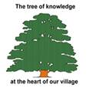 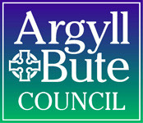

Head Teacher: Mrs Maria McArthur Garelochhead Primary and ELC
Feorlin Way, Garelochhead, G84 ODG
Tel: (01436) 810322
Our Ref: Uniform Your Ref:
If phoning or calling please ask for:
Mrs Maria McArthur
e-mail: enquiries-garelochhead@argyll-bute.gov.uk

SCHOOL UNIFORM

Our supplier for jumpers and cardigans with the school logo is Tesco. The school gets 5% money back on any purchase which we will use to purchase more resources for the children.
You can purchase these items using the following link:

www.myclothing.com

We have now added a link for our PE uniform for you to order these items easily at the same time. The company also provides other items such as white shirts, gym bags etc. Please remember that you are free to purchase these kinds of items from any company you choose.

School ties are only available to purchase from the school office – please call in at any time to purchase one. The cost per tie is £3.50.

Thank you.

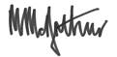
Head Teacher

